Create custom certificate

Click dashboard menu and select custom certificate.

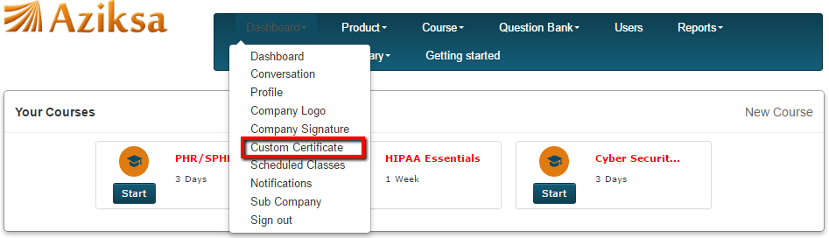

On this page, you see the list of previously created custom certificate and button to create new certificate. Click on New Custom Certificate button.

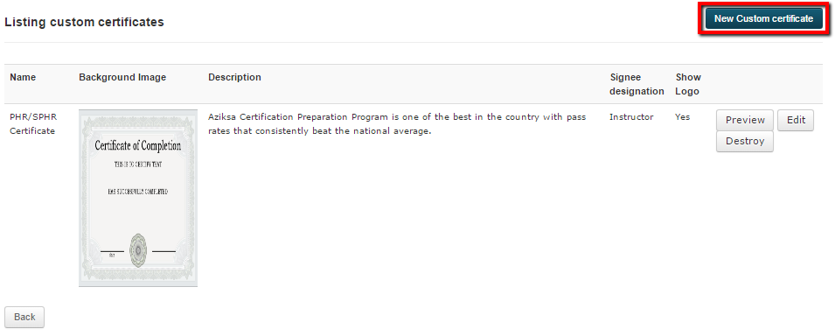

Enter the certificate data, then click Submit button.

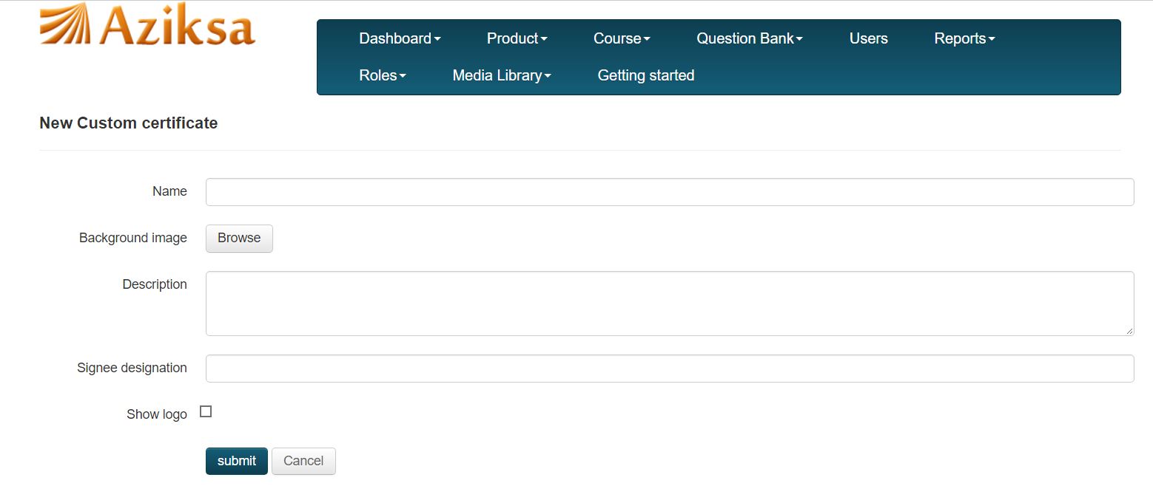

It will display a successful message and list the certificate you just created.

