Send emails to users

On dashboard, click on “Start” button for your course, it will take you to Course details page.

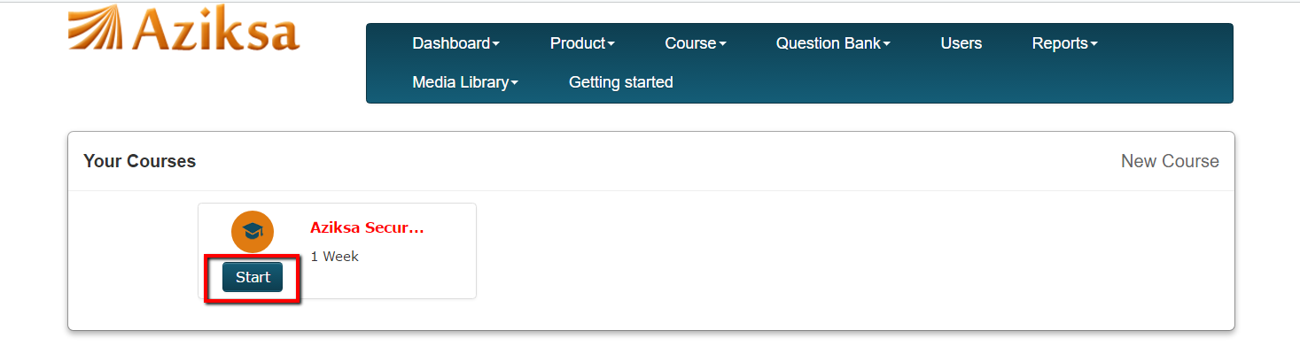

There could be multiple classes for the same course. Select the class, click on action menu to see the Compose Email link.

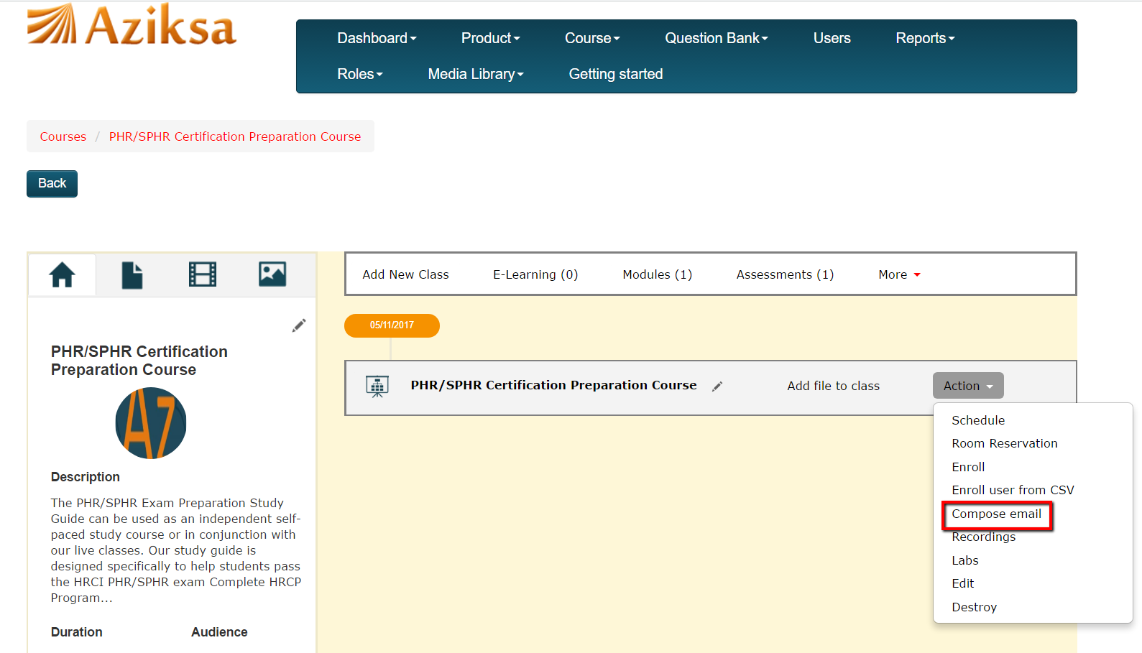

On this page, you can create a new message template or select one from the list.

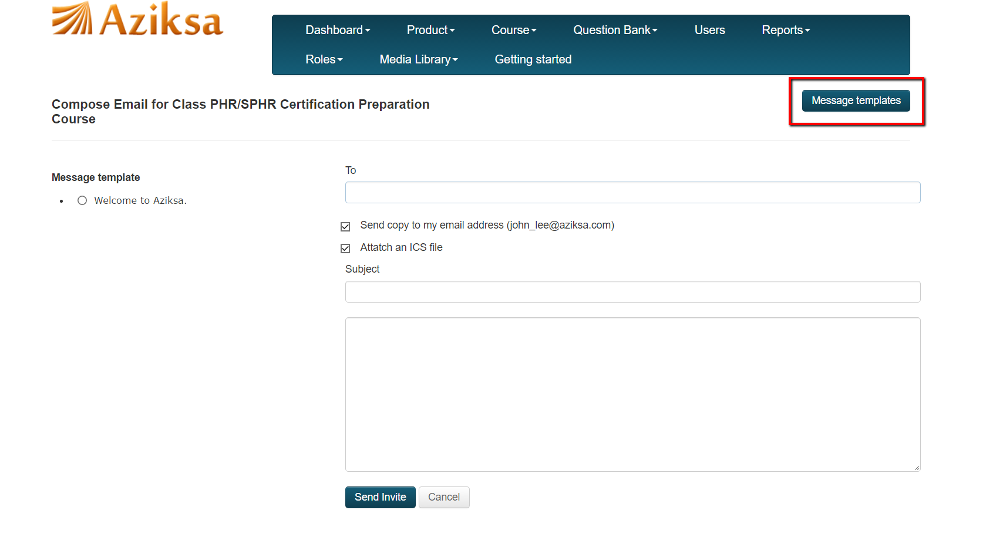

Click on new message template.

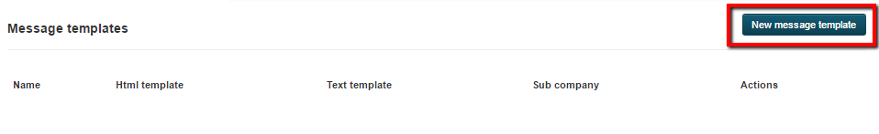

On message template page, enter all the required data then click submit. It will create a new message template for you. Now you can select your newly created message template and send the email to your class.

Aziksa provides you the option to attach your class schedule with your email. This attachment can be saved locally inside your end user mail client such as outlook, Gmail etc.
