Enroll users in self-paced courses

On dashboard, click on “Start” button, it will take you to Course details page.

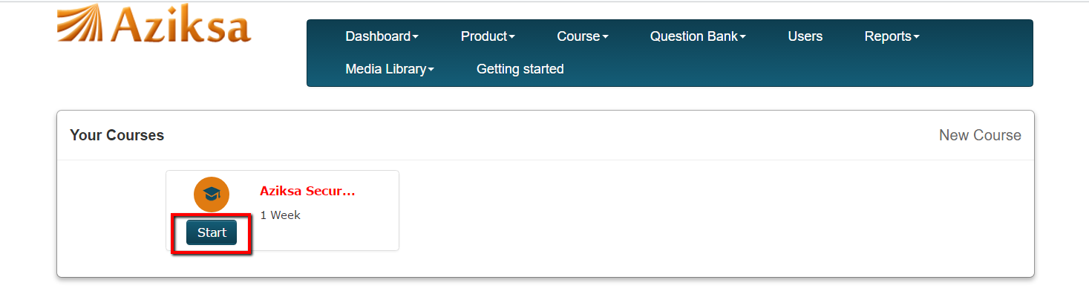

You will see the following course detail page. To enroll one user at a time, click on enroll.

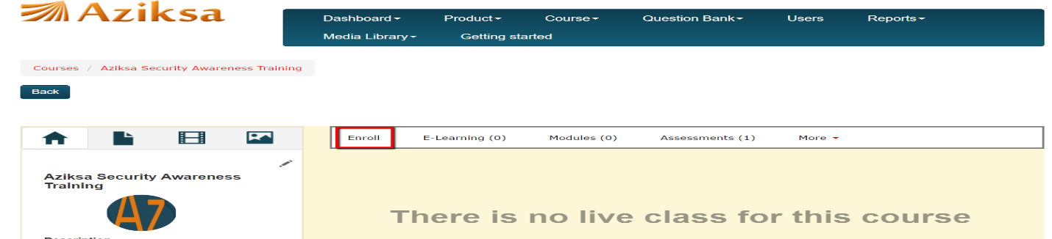

Next it will present you a list of unenrolled users (left column) and enrolled users (right column).
Click the checkbox next to unenrolled user and system will move the user to enrolled column.

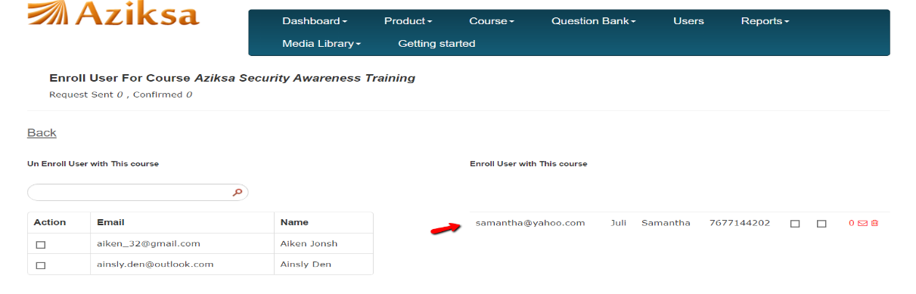

Back button will take you to course detail page.

To enroll multiple users from a CSV file, click on More menu and select “Enroll user from CSV”.

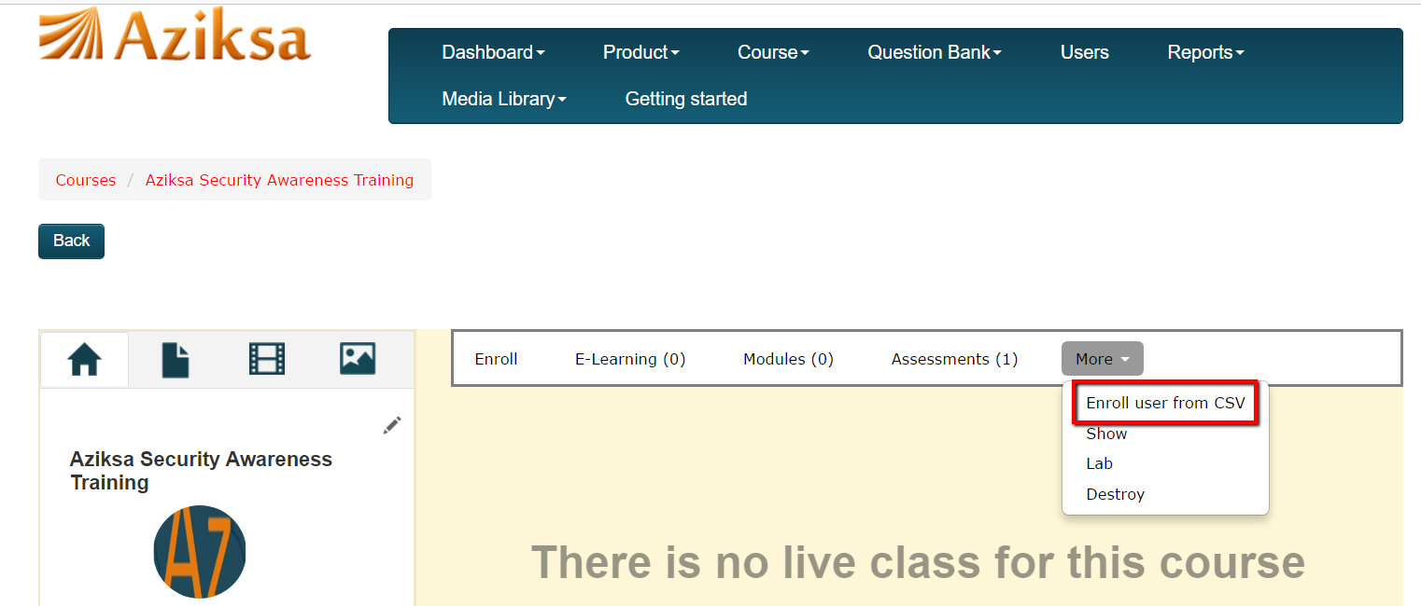

Click on Browse button to select the CSV file from your system. Click Submit after CSV file selection. It will take you Courses summary page.

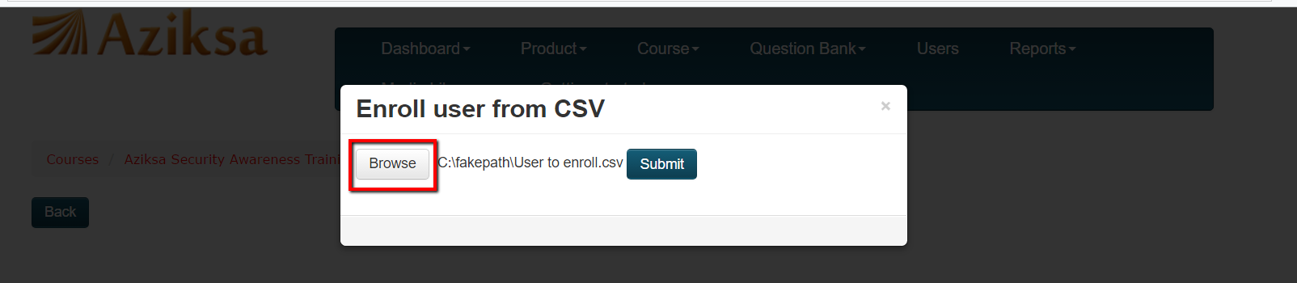

To see your enrolled users, click on enroll button for your course.

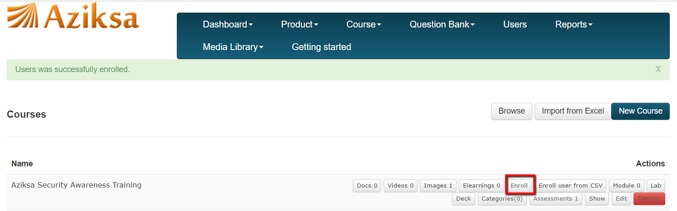

Sample course enrollment page.

