Create Instructors

To create Instructor, click on Users button.

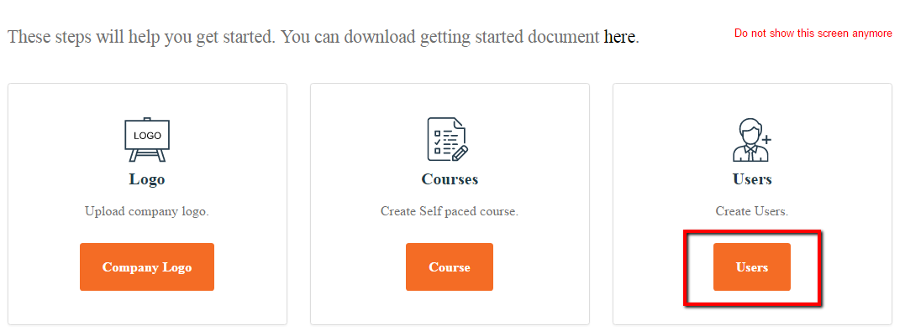

Click on “Add New User” to create one user at a time.

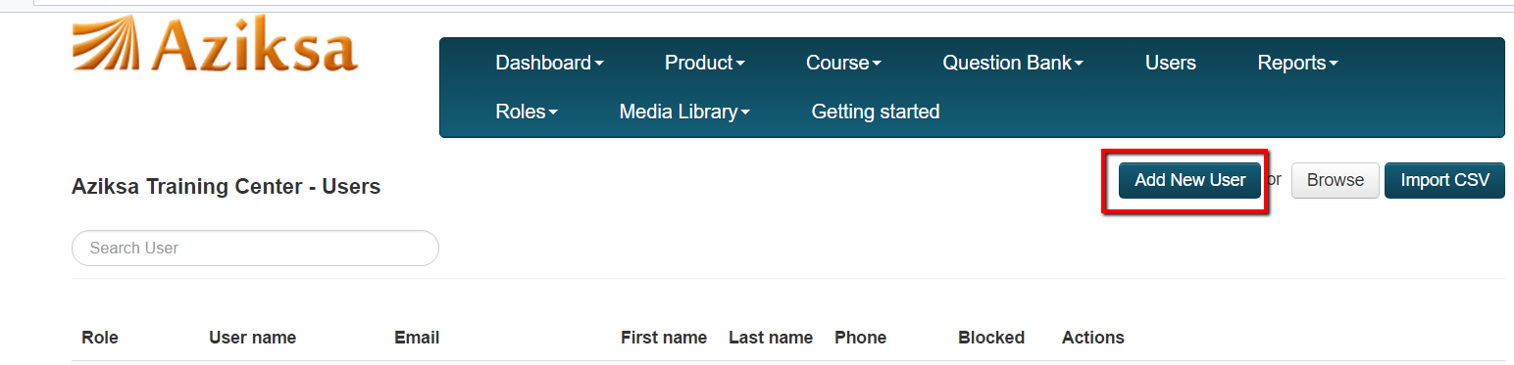

Select Instructor from User Type dropdown and enter all other information. Click Create User button. System will send an email to user with confirmation link.

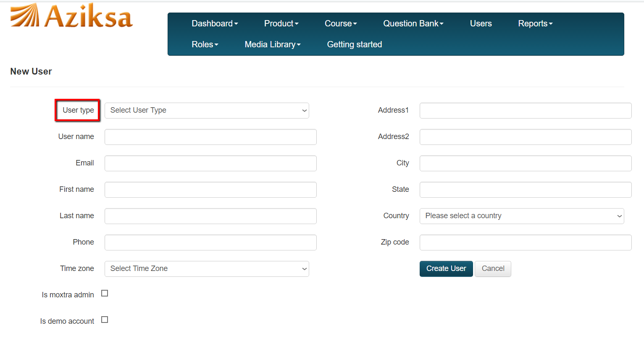

Here is sample confirmation email to the Instructor.

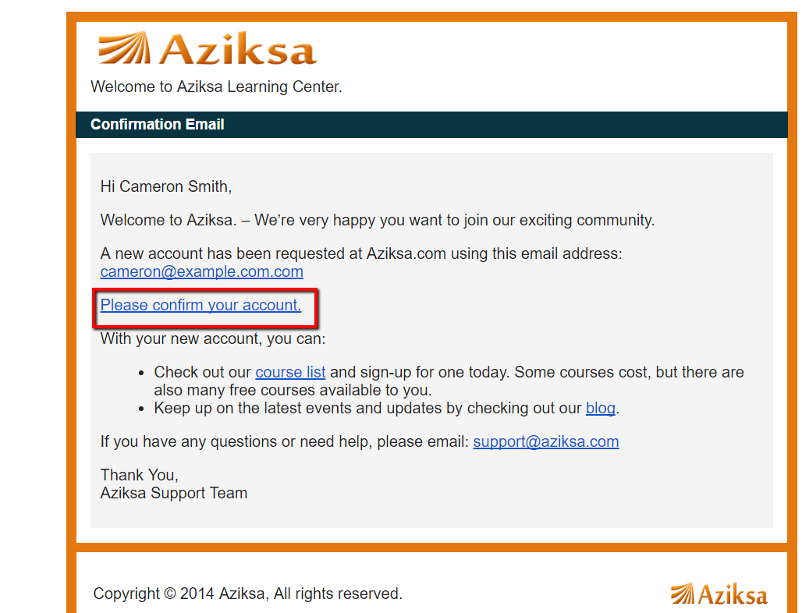

Once Instructor clicks of the confirmation link in the email, system will present this page to update any missing information and choose a password.

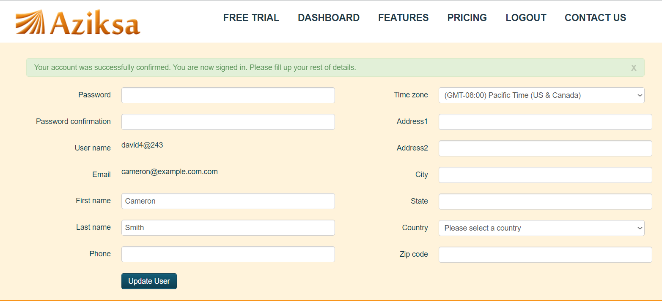

Sample Instructor dashboard.

