Create users
There are multiple ways to create a user in Aziksa by admin. You can create users by uploading an excel file with user data or you can use the form to create one user at a time. When you use form, the system will send an email to the user with a confirmation link. All users created by uploading excel file are confirmed users. They do not get emails to confirm their account.

Anyone, who buys a course on site is self-registered and enrolled in the course with no admin task.

To create user, click on Users button.

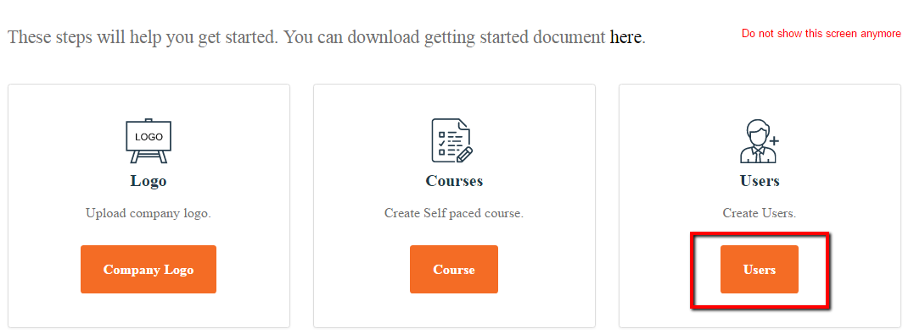

Click on “Add New User” to create one user at a time.

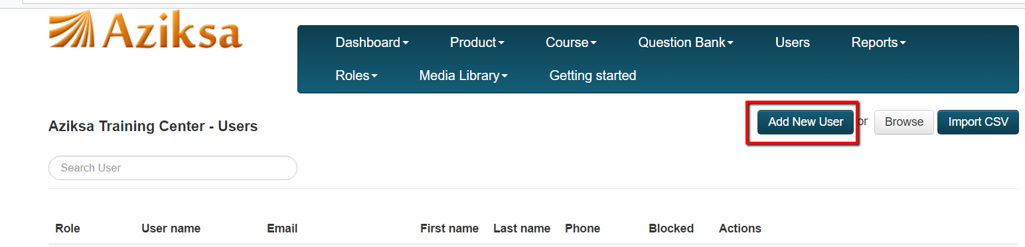

Select Company Trainee from User Type dropdown and enter all other information. Click Create User button. System will send an email to user with confirmation link.

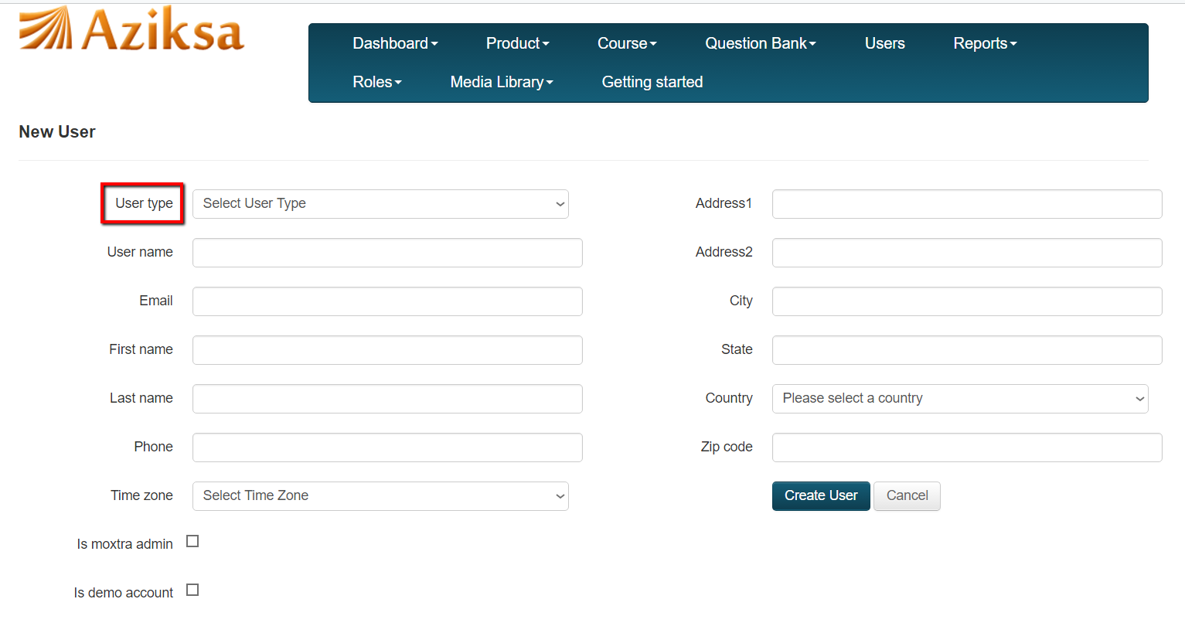

Here is sample confirmation email to the user.

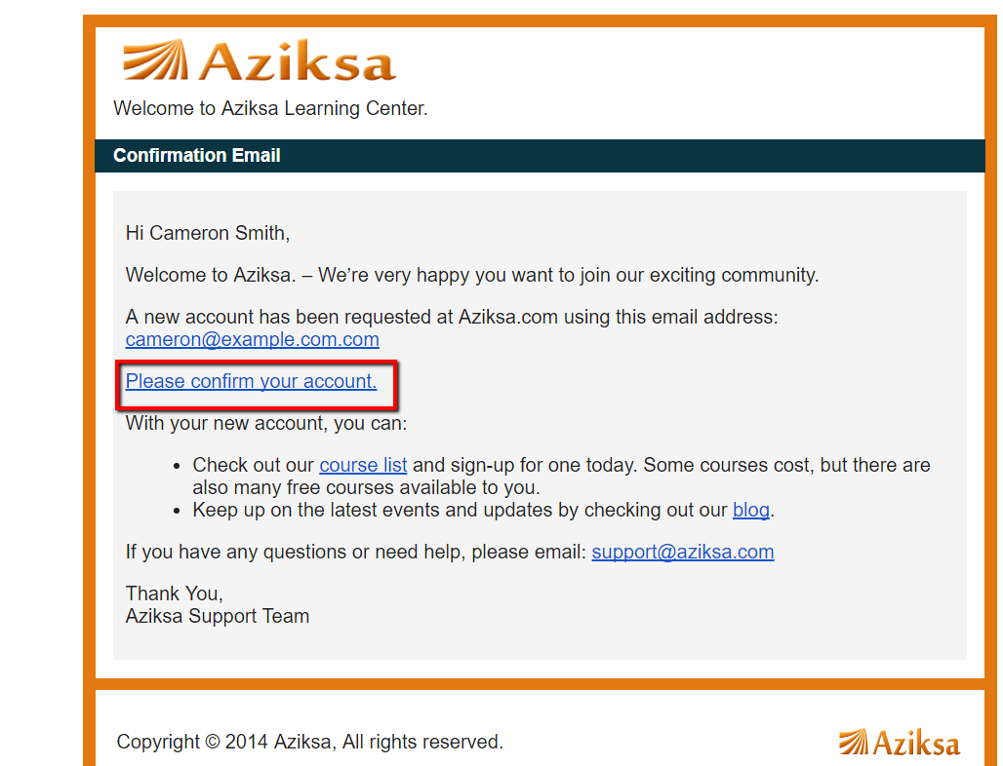

Once user clicks of the confirmation link in the email, system will present this page to update any missing information and choose a password.

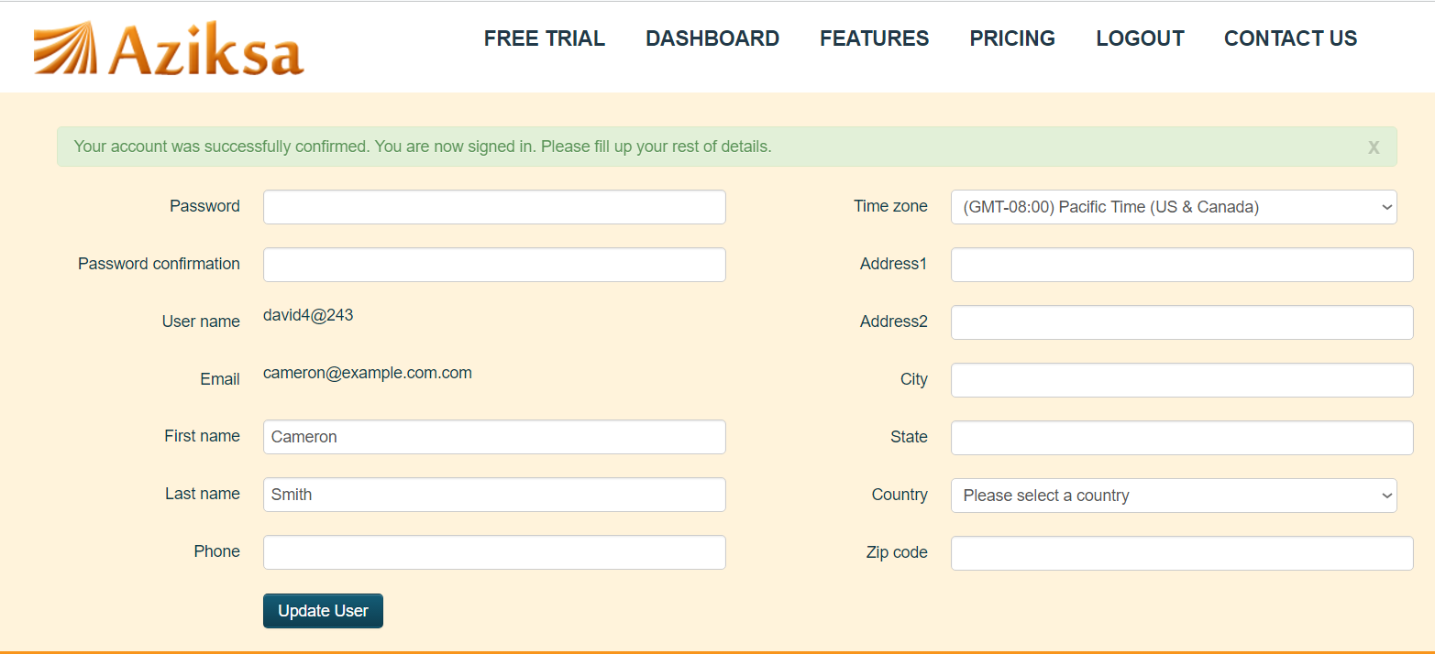

Here is a sample user Dashboard.

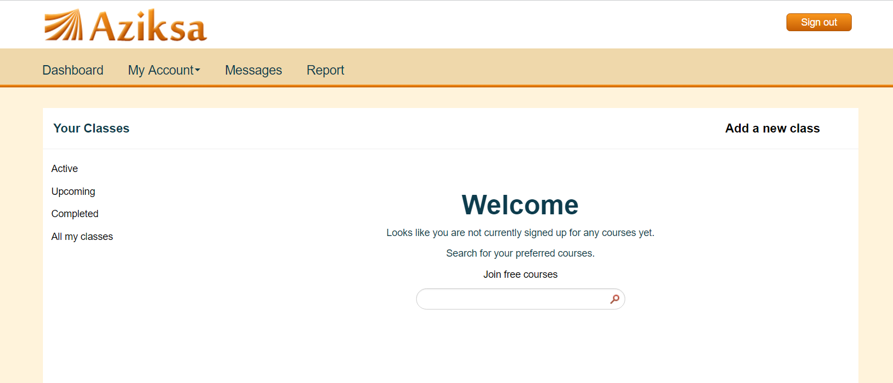

To create multiple confirmed users, click “Browse” and select CSV file with user data.

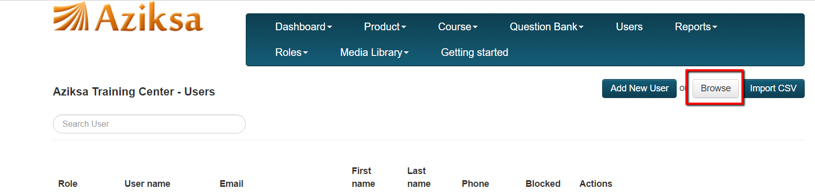

Click on Import CSV button and follow the prompt.
You can send an email to support@aziksa.com to get a sample template for csv file.

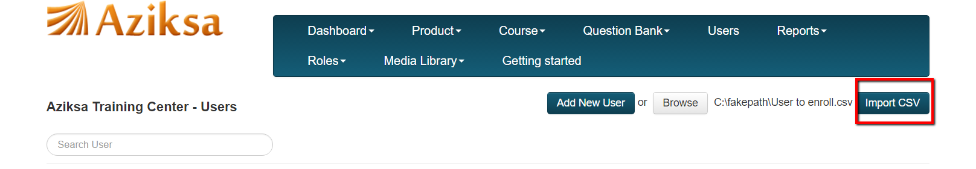

After successful file import, you will see this message.

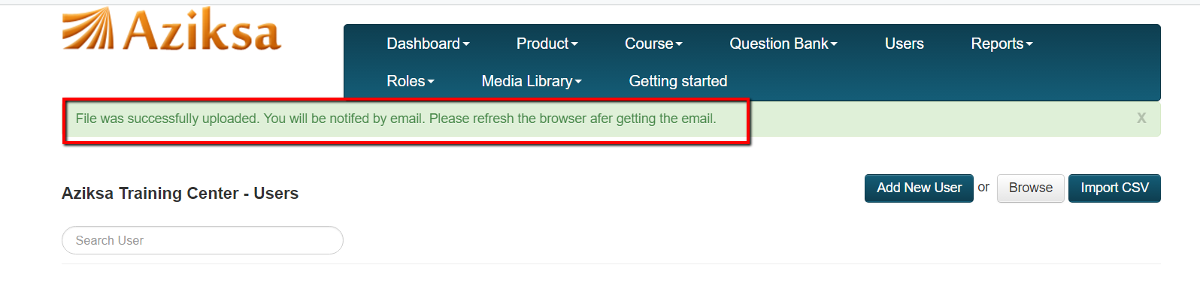

After refreshing the page, you can see the created users.

