Upload your company logo

Click on upload button on getting started page and follow the prompt.

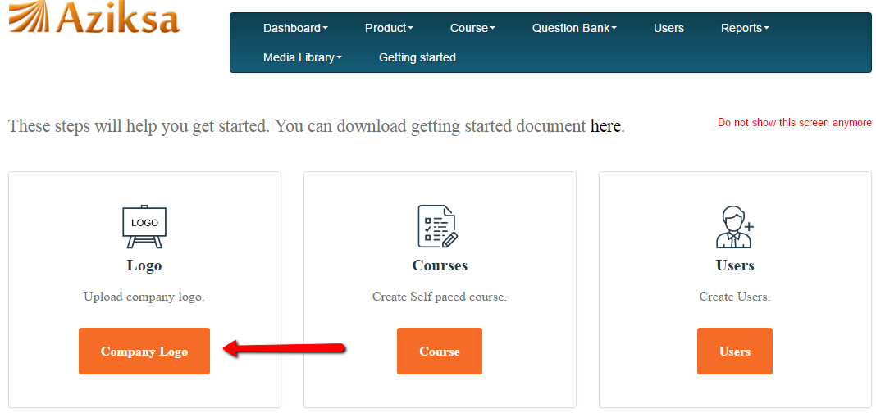

Click on new company logo button.

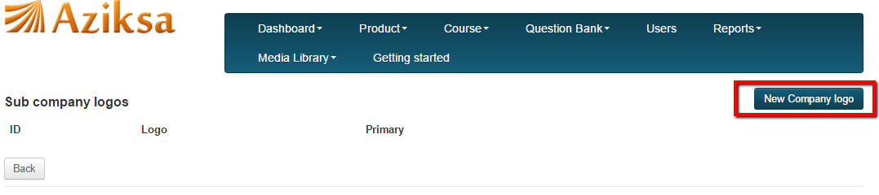

On this page click browse to pick your logo image file from your desktop.

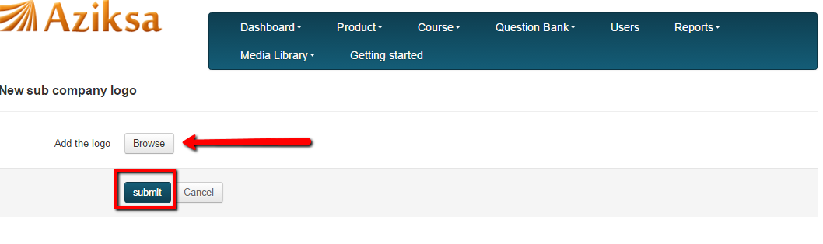

On this page, select the Primary Checkbox, Now, it will change the company logo.

