Create your company

You create your company during your company registration. Click on free trial link from home page and/or pricing page.

On free trial page, select the Service Type and Number of Users.

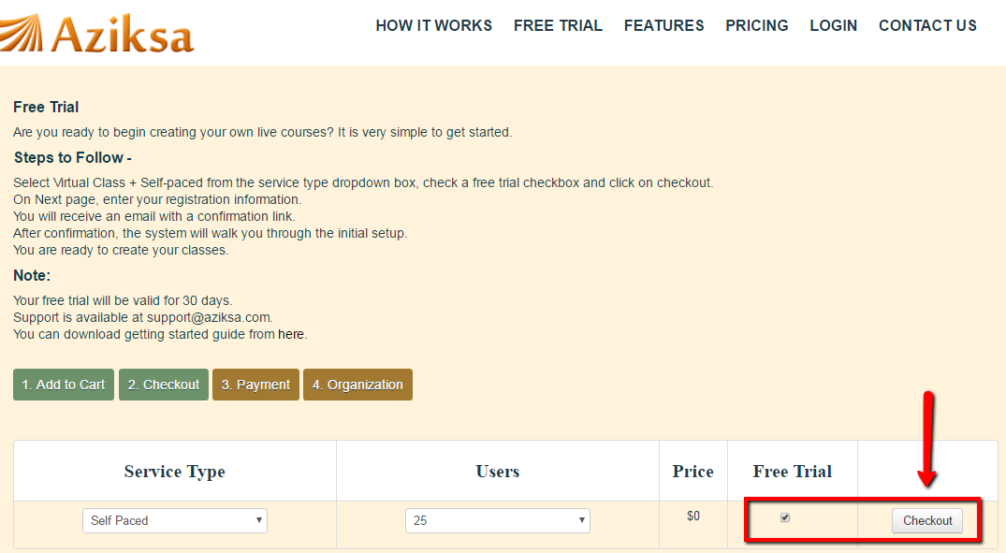

Enter all required details then click Submit button.

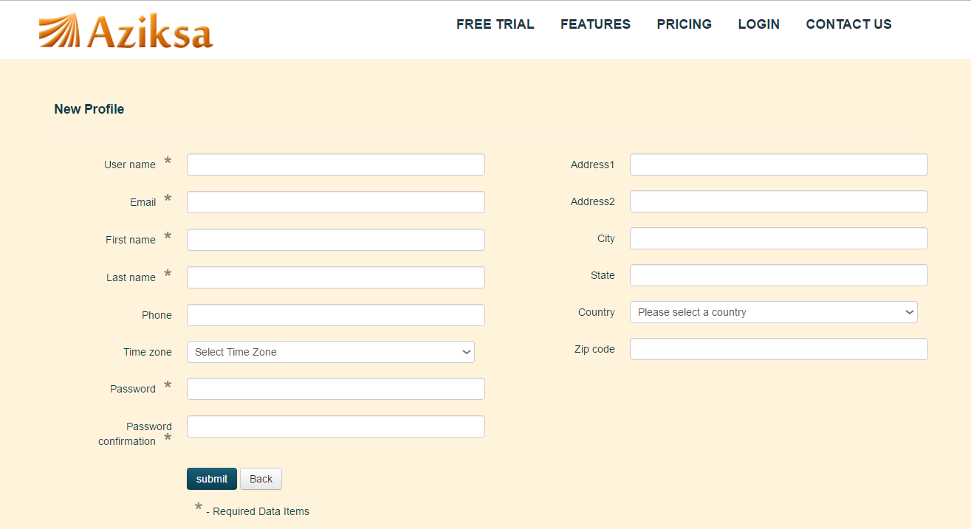

You will get a confirmation e-mail. Open your email and click confirm. It will take you Edit Profile & Create your organization page. Enter all required details then click Submit button.

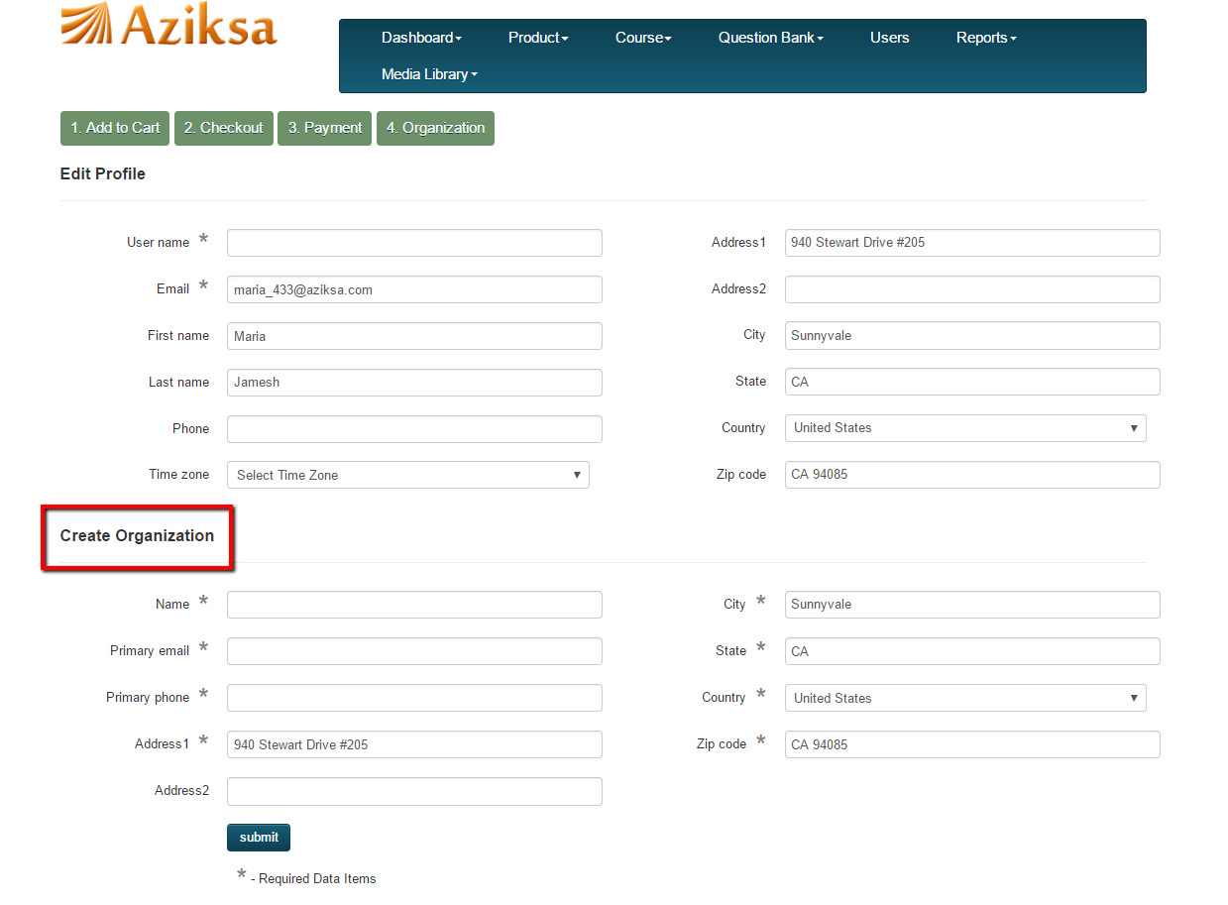

You have completed creating your organization. Now you can start your setup by uploading logo, creating courses, registering your users to name a few.

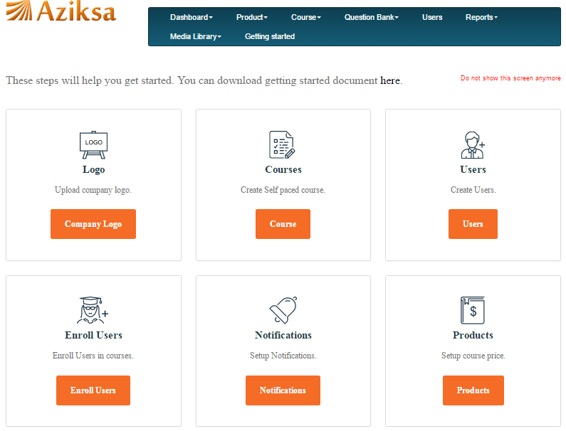

You can edit your organization information by clicking on dashboard and sub company as shown here.

