Manage media library

Click Media Library.

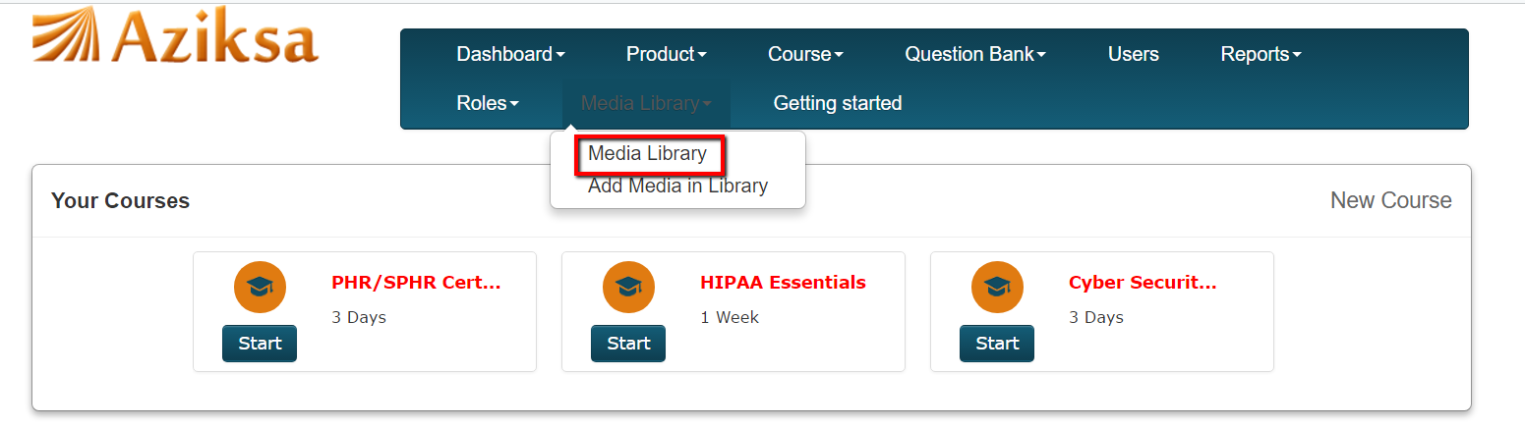

Click Browse to upload the multiple videos or Click New video to upload the single video in Media Library.

