Click “Reports” It will show you all the reports in dropdown. Click the report name that you want to run.

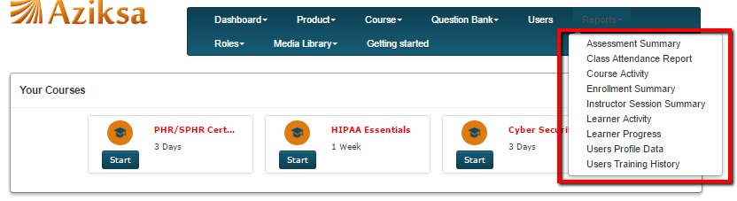

Next it will give you options to select your report columns and limit the data by selecting course, date etc.

Report Name: Assessment Summary

Select the report columns, course and click submit button.

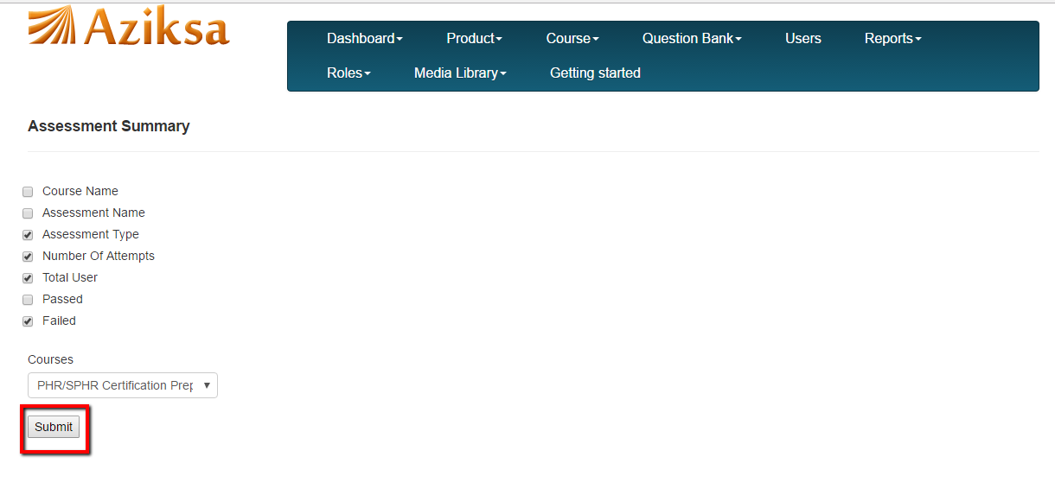
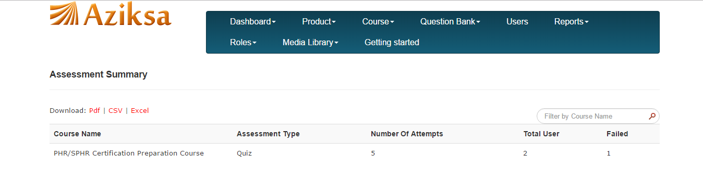

If you do not select a course and report columns. It will display you all the courses assessment summary.

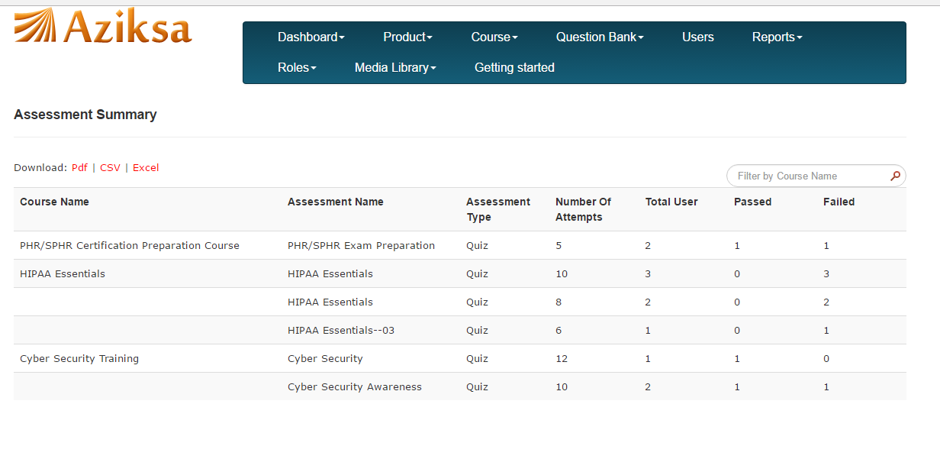
Click on Pdf/CSV/Excel file link to download the Assessment Report.

Report Name: Class Attendance

Select the start date, end date and name of the class. Click submit.

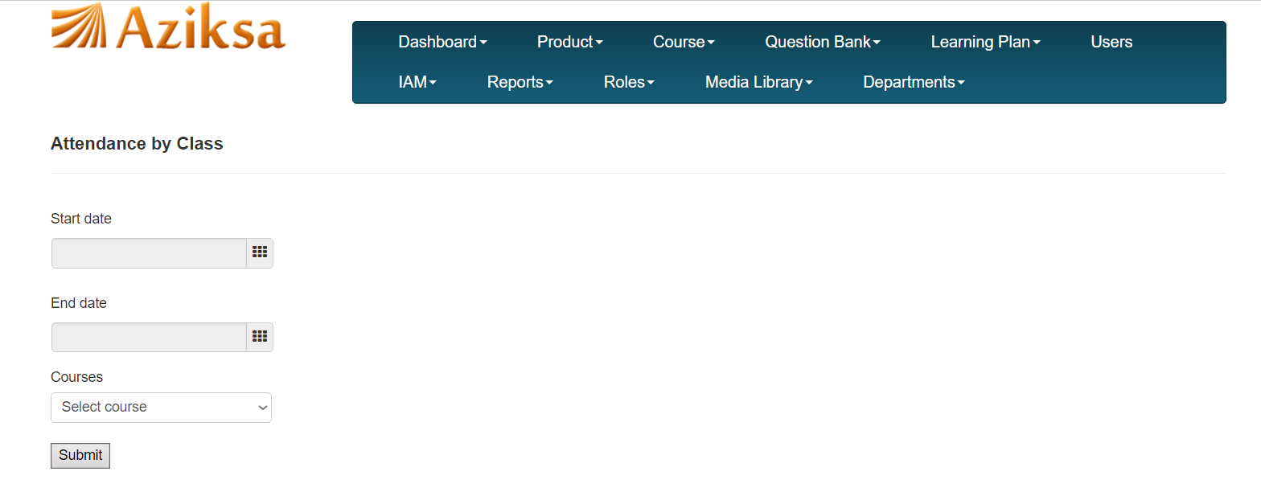

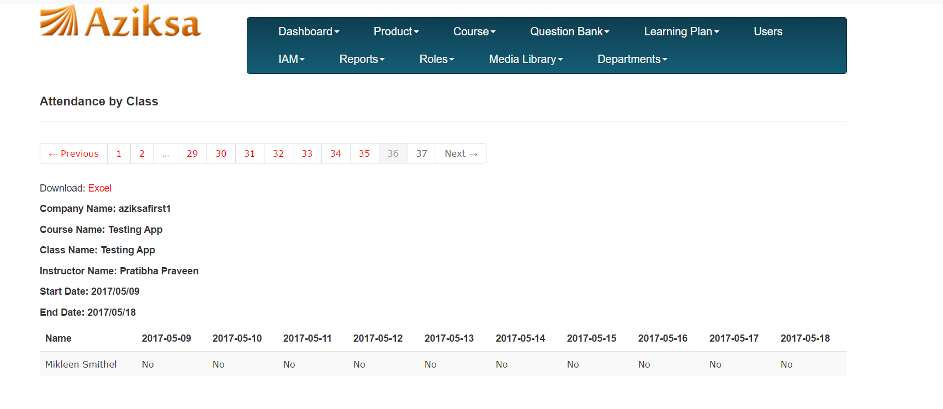

Click on Excel file link to download the Attendance Report.

Report Name: Course Activity.

Select report columns and course. Click Submit.

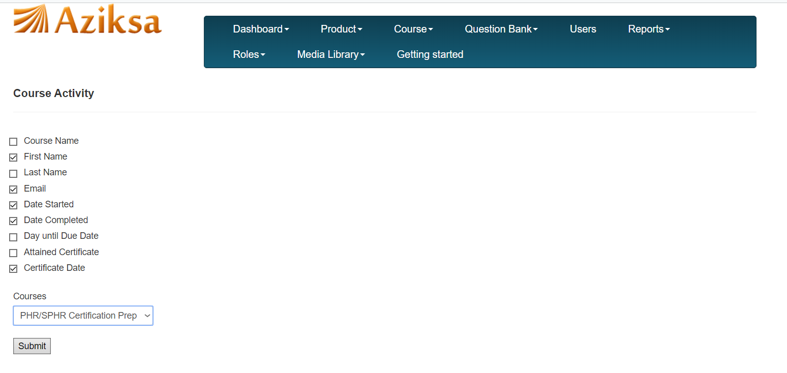

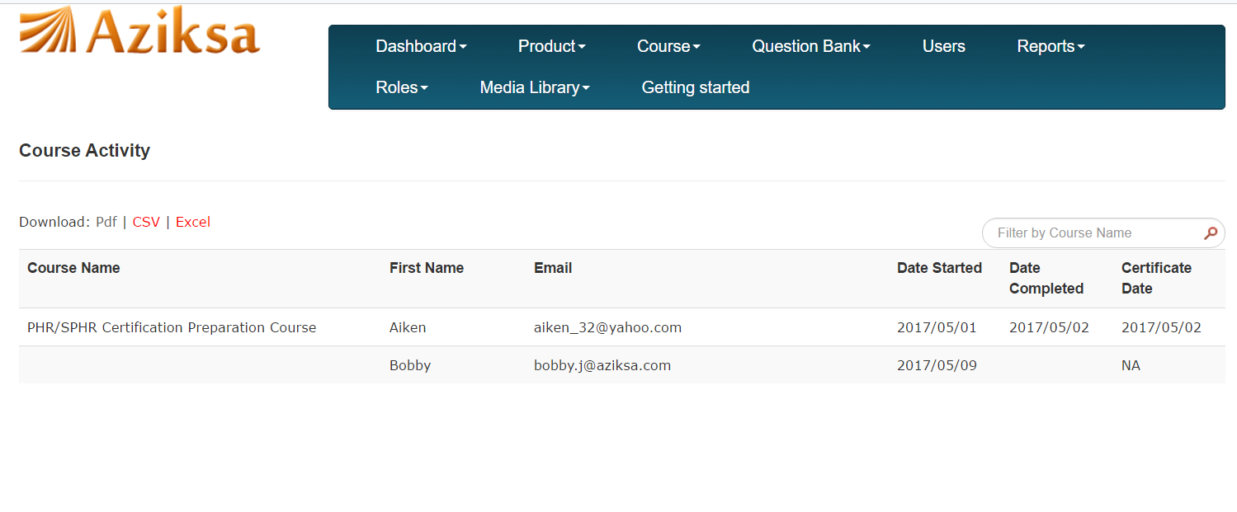

If you do not select any report columns or course, it will display all courses.
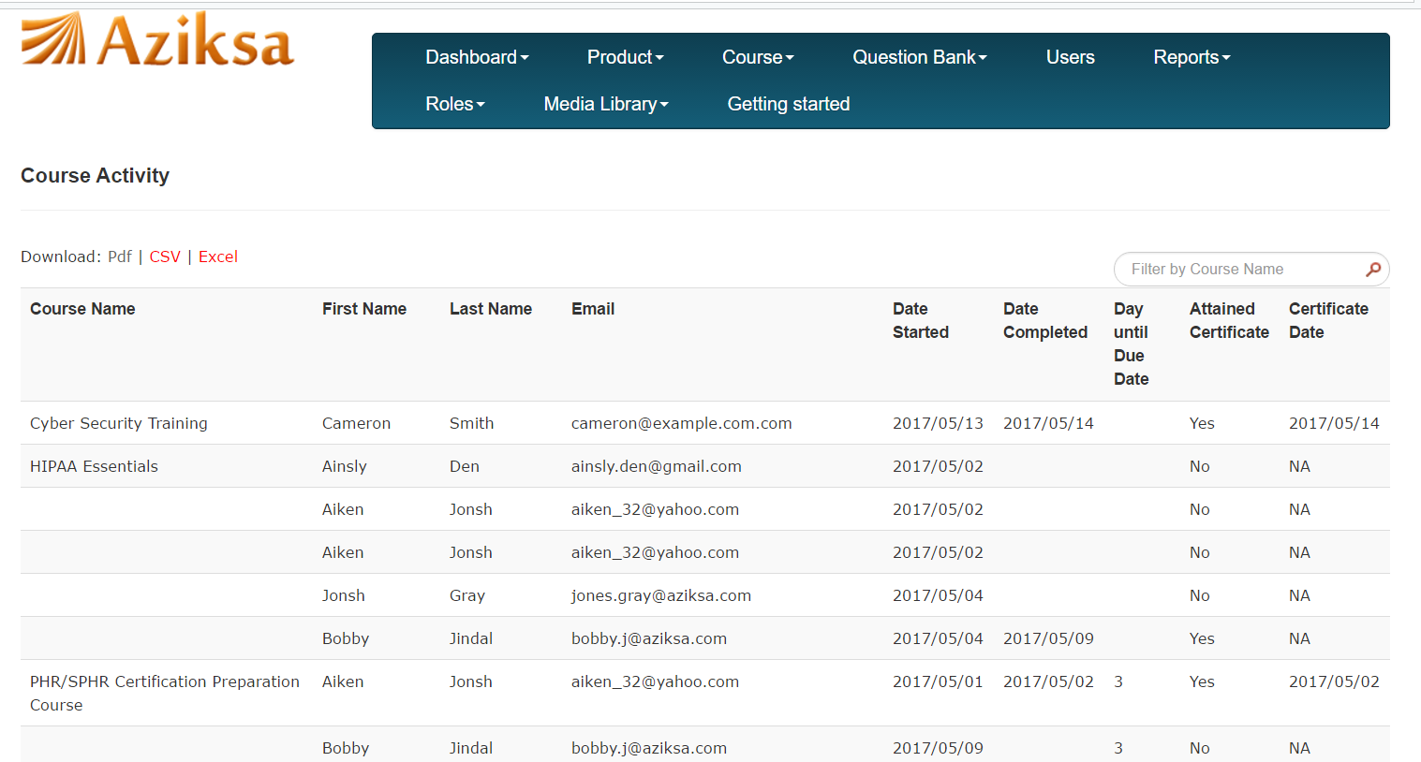

Click on Pdf/CSV/Excel file link to download the Course Activity Report.

Report Name: Enrollment Summary

Click + sign as shown here to see the enrollment detail for the course.

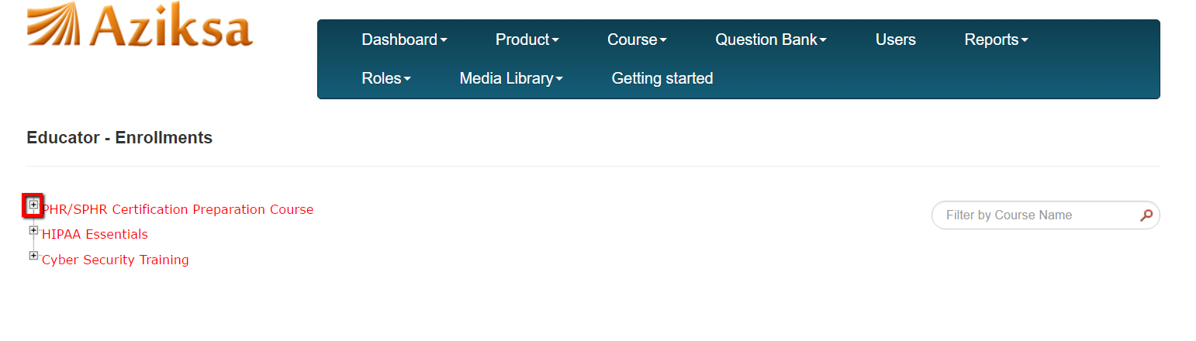
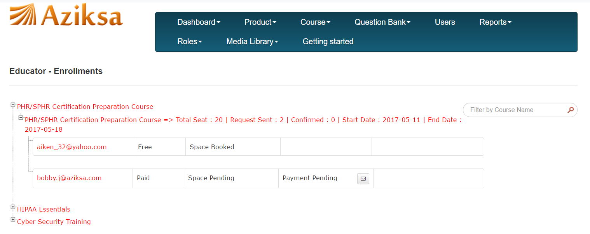

Report Name: Instructor Session Summary

Select the report columns, course and click submit button.

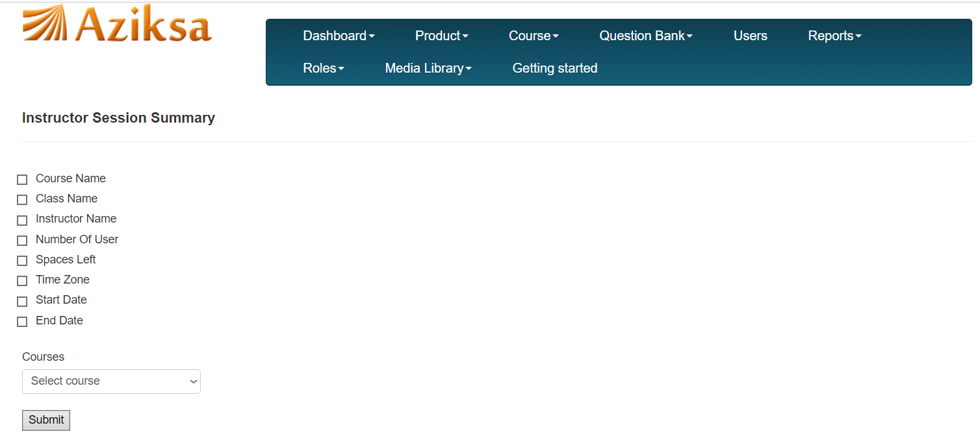
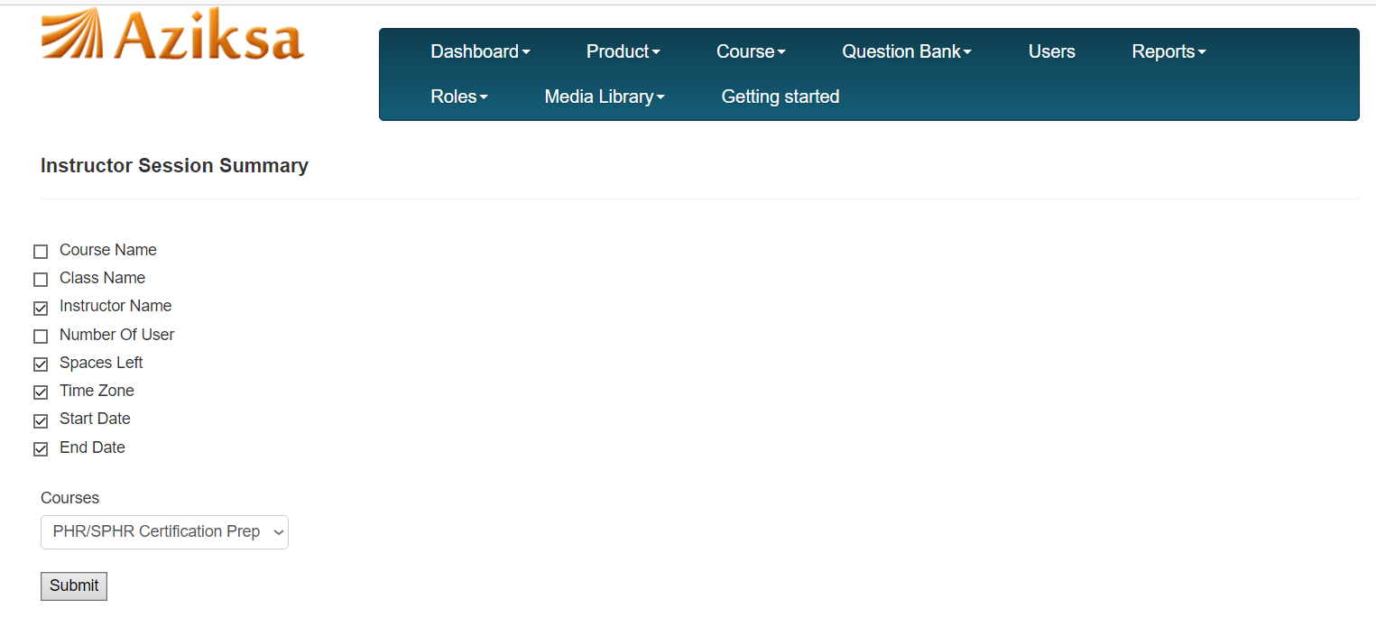
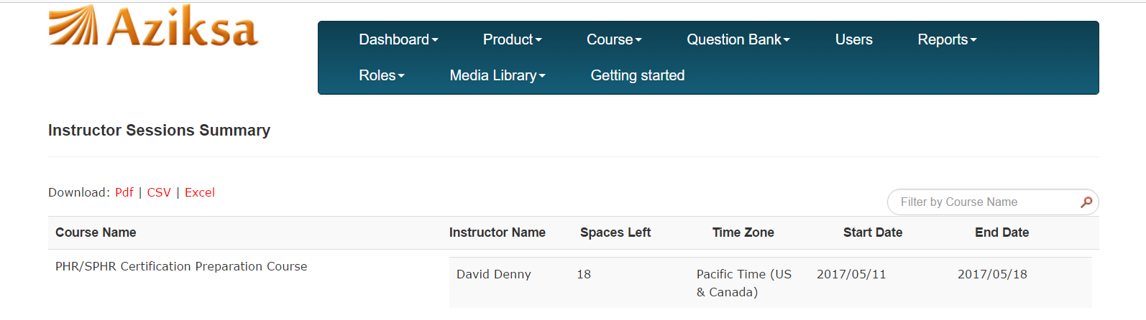

If you do not select any report columns and course, it will display the summary for all courses.

Click on Pdf/CSV/Excel file link to download the Instructor Session Summary Report.

Report Name: Learner Activity

Select the report columns, course and click submit button.

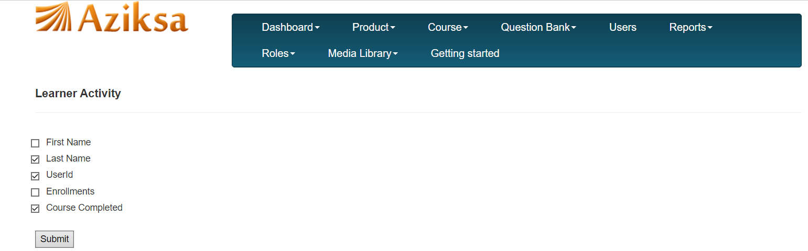

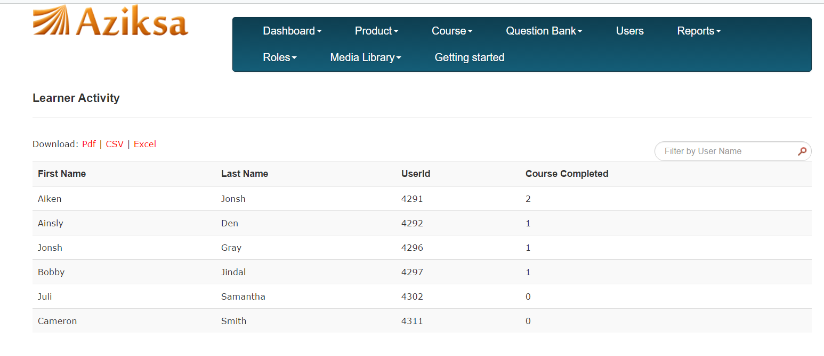

If you do not select report columns and course, it will show learner activity summary for all courses.

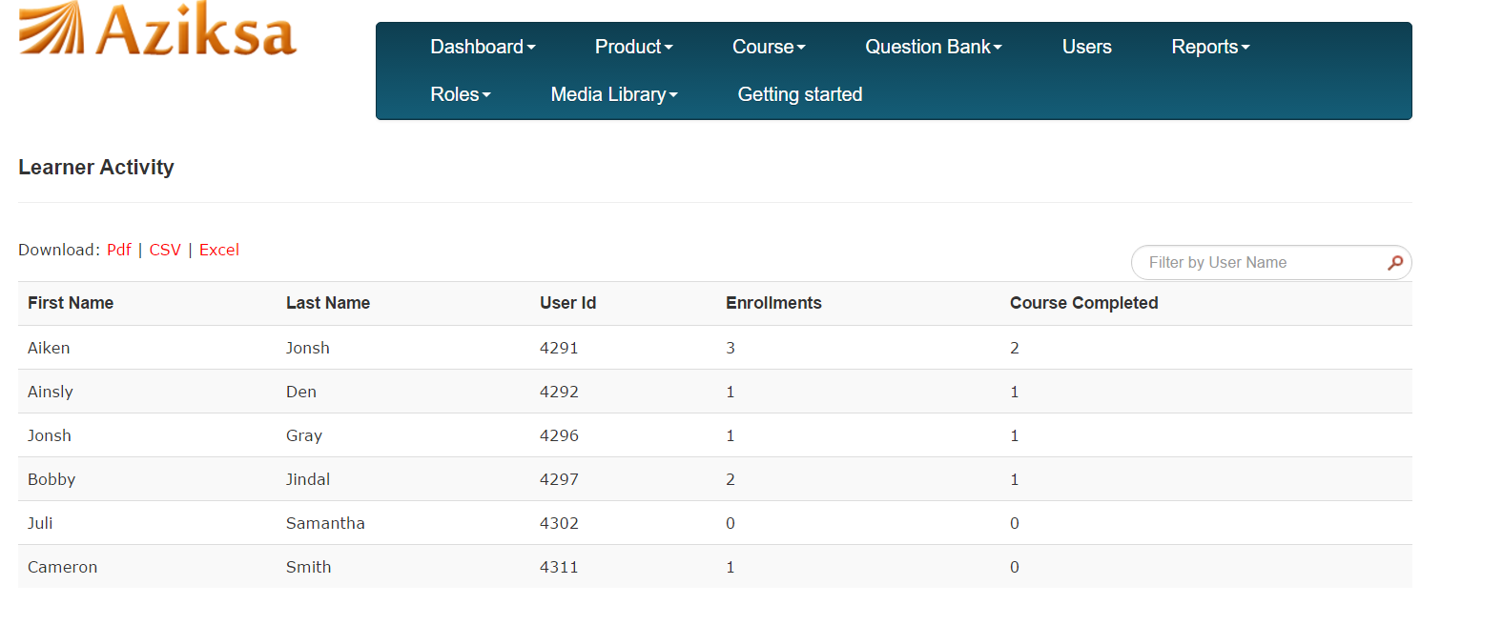
Click on Pdf/CSV/Excel file link to download the Instructor Learner Activity Report.

Report Name: Learner Progress

Select the report columns, course and click submit button.

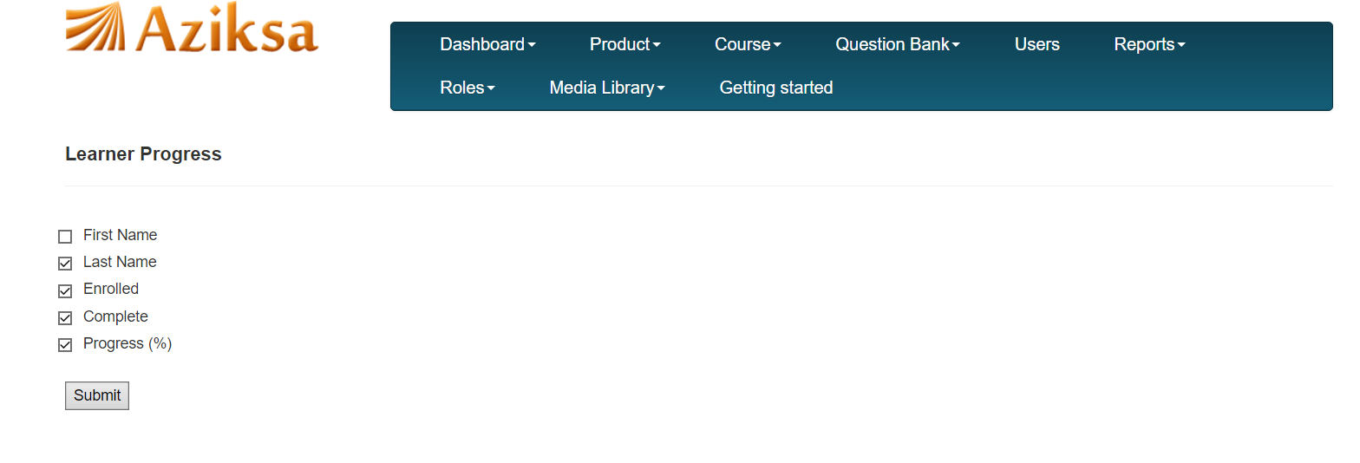

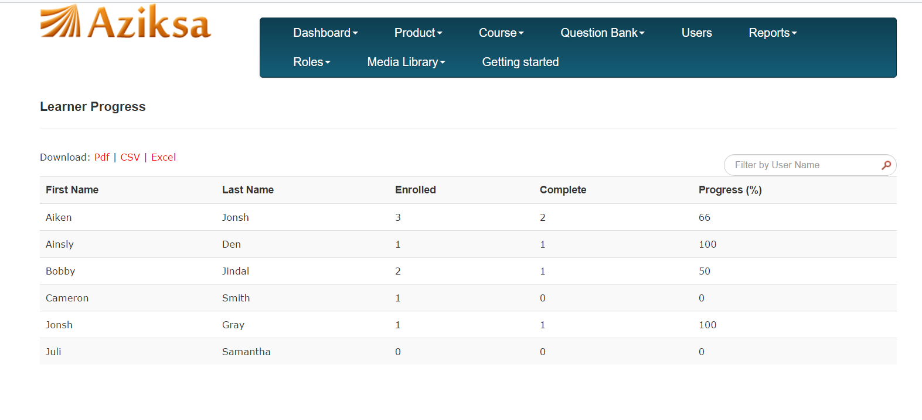

If you do not select report columns and course, it will show learner progress for all courses.

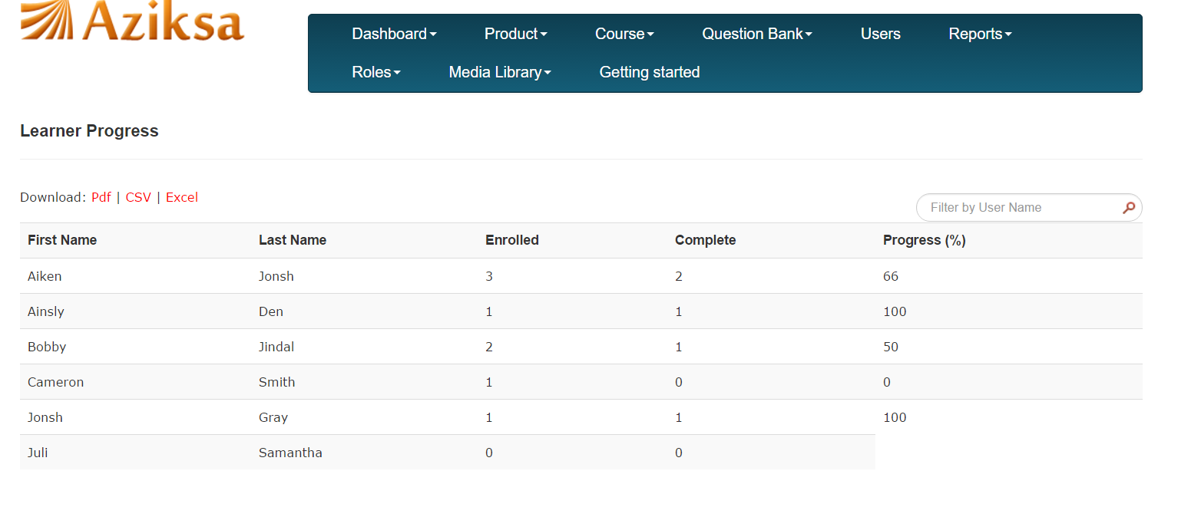

Report Name: User profile data

Select the report columns and click submit button.

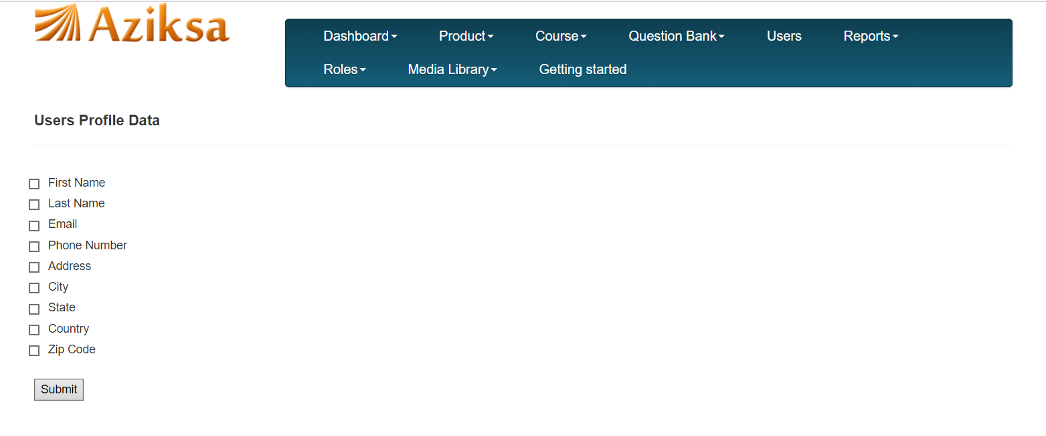
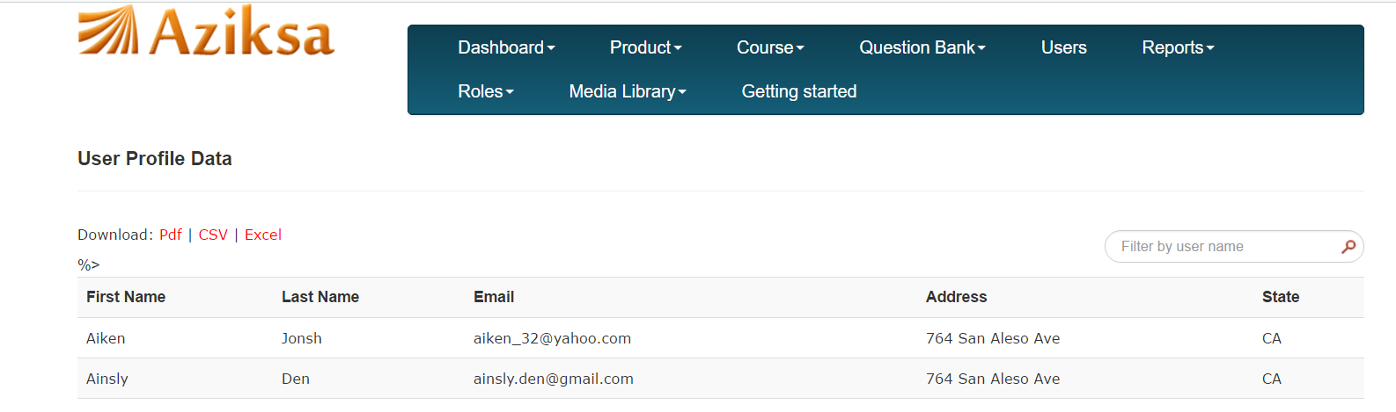

Report Name: User training history

The report will list all your users and a training history button for each user. Click on training history button to see the training details of each user.

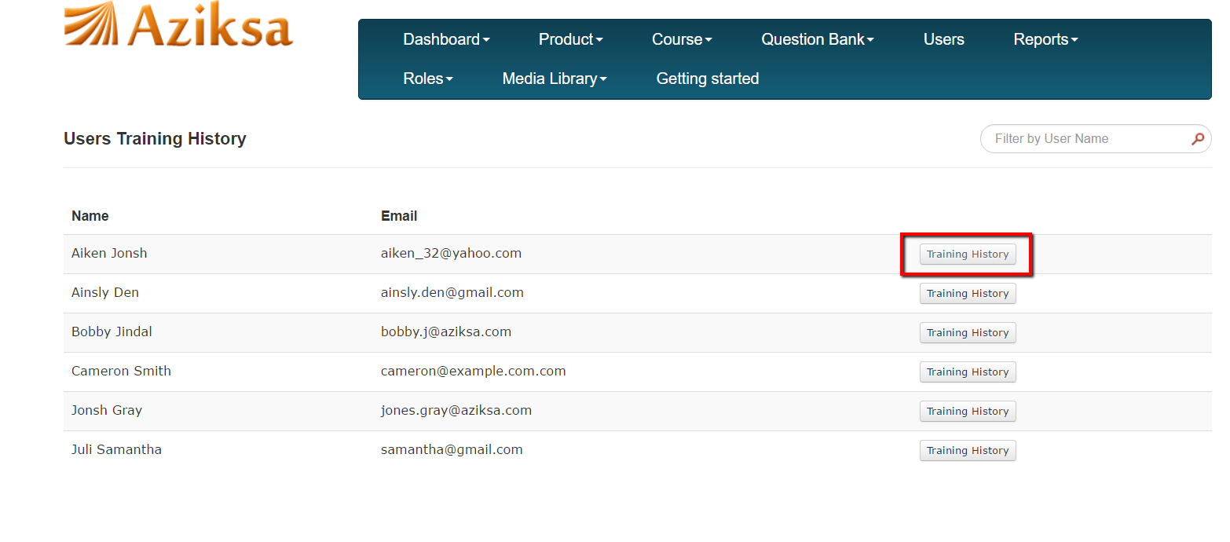

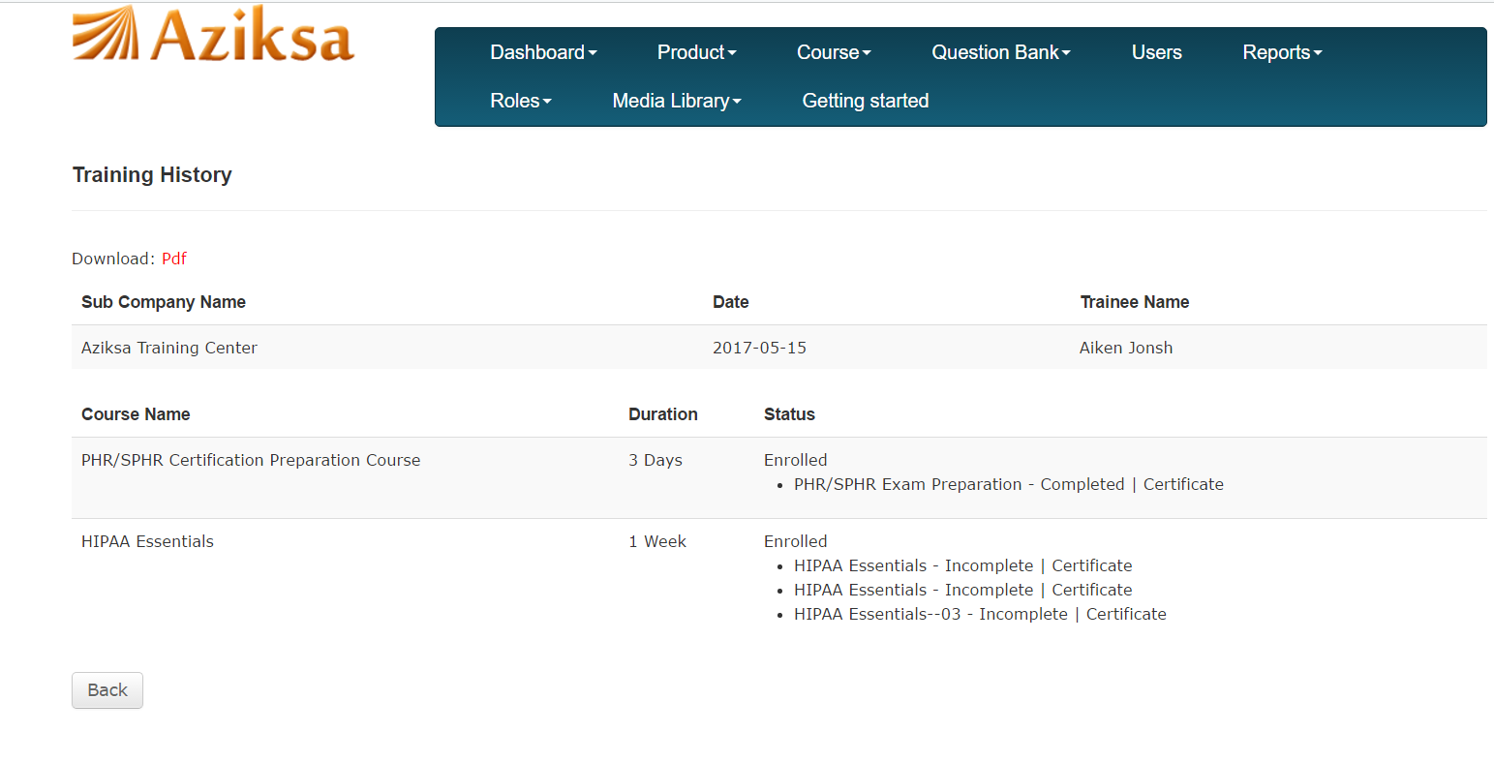

Click “Pdf” to download the Training History of a user.

