Setup price
Click “Products”, It will take you Product page.

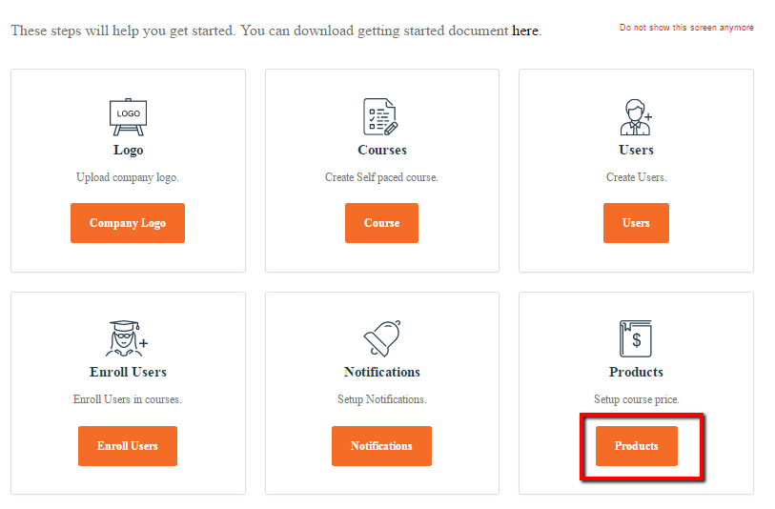

System creates a product by itself for every course, you create. To set a price for your course, just select the edit button of the product with same name as of your course.

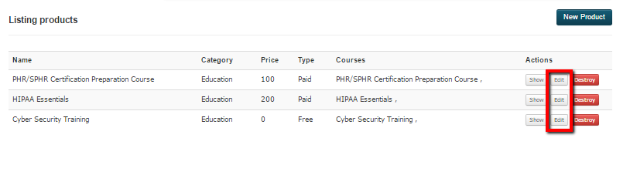

Select paid or free for the product type and type in your price for the paid course. Cli.ck update product button to save the changes

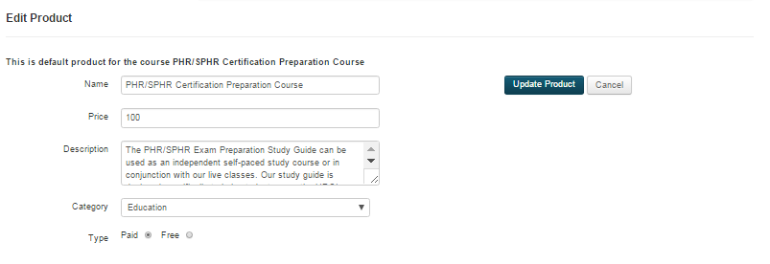

Aziksa allows you to create a certification product by combining multiple courses. Click “New Product”.

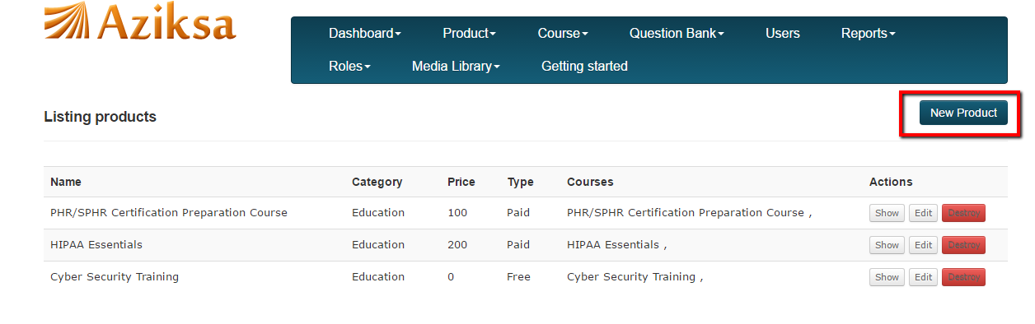

Enter data, select the list of courses you want to include in your product Click Submit.

