Setup notifications

Click Notification as shown here.
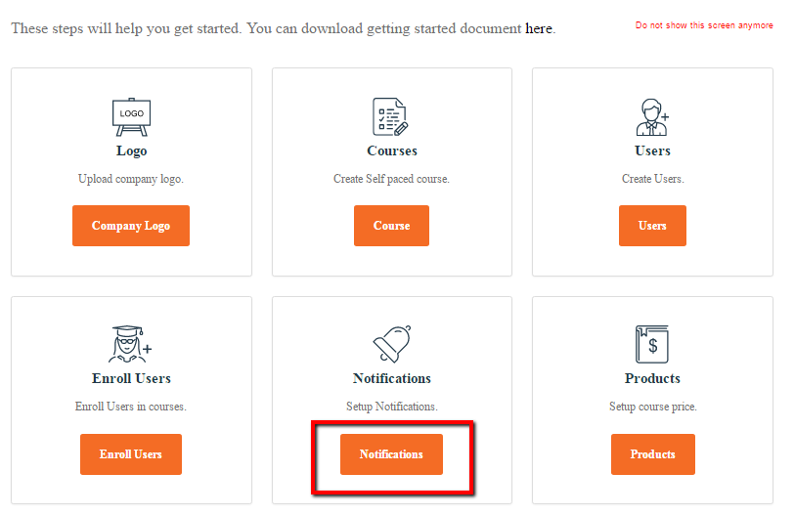

Aziksa provides you the notification for the following events.

- Course has been deleted
- Course has expired
- ILT Session Changed
- ILT Session Deleted
- ILT Session Today
- User Enrollment
- User Un-enrollment
- User Deleted
- Certification Issued
- Certification Expired

Click New Notification

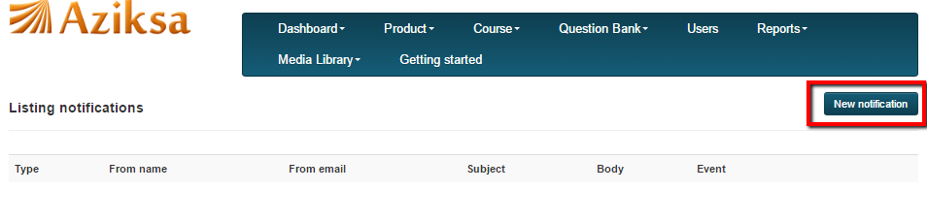

Select the notification type from drop down box, type-in the information and click submit button.

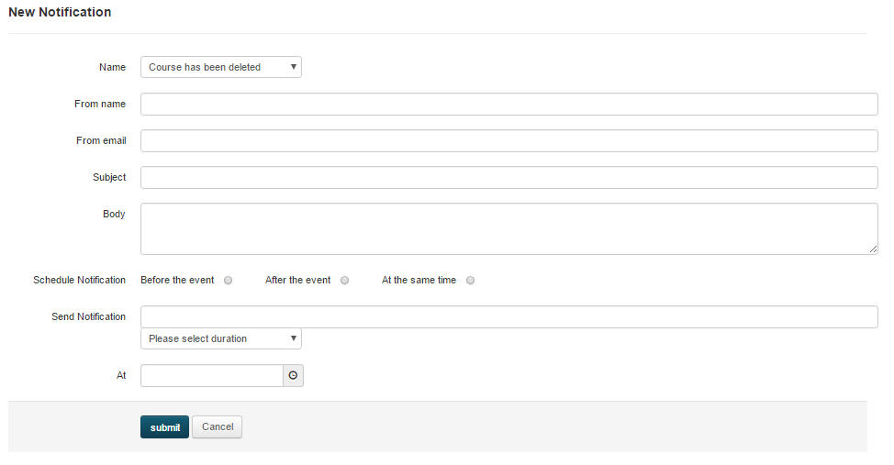

Sample listing of Notifications.

