Assign instructors to live virtual classes

On dashboard, click on “Start” button, it will take you to Course details page.

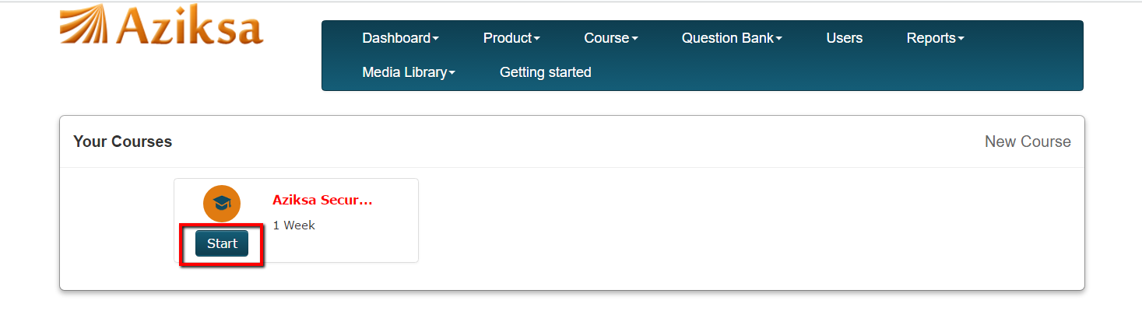

Click Class name, it will display class details.

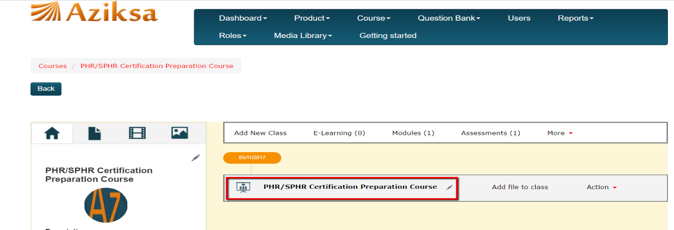

Select instructor from dropdown menu and click Submit. It will take you on course details page and system displays a successful message.

