Enroll users in live classes
On dashboard, click on “Start” button, it will take you to Course details page.

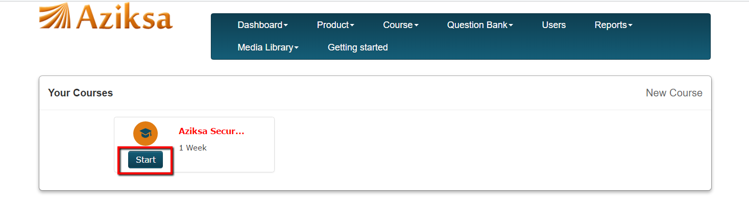

You will see the following course detail page. To enroll one user at a time, click on enroll.

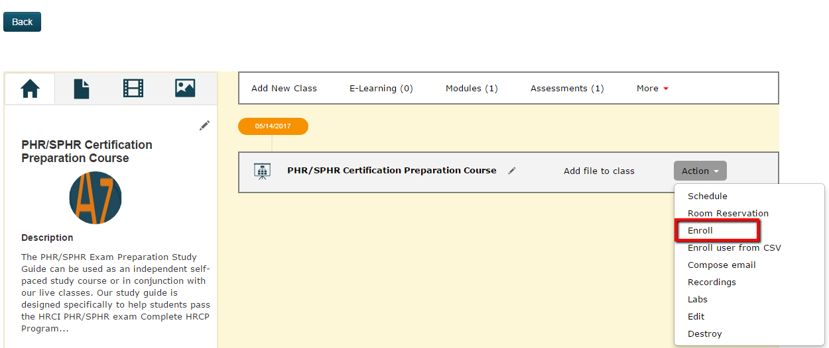

Next it will present you a list of unenrolled users (left column) and enrolled users (right column).
Click the checkbox next to unenrolled user and system will move the user to enrolled column. If a class has already started then it will ask you to change class dates, before you can enroll the users.

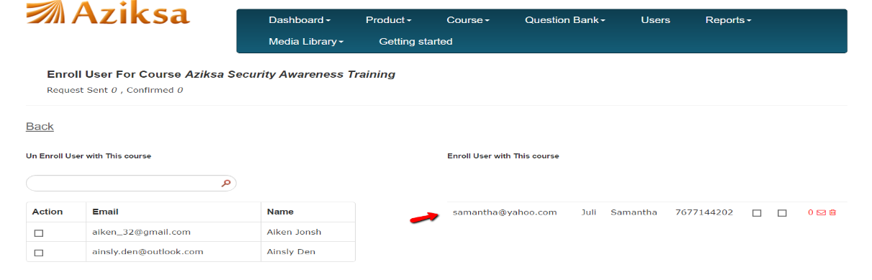

Click back button. It will take you course details page.

You can enroll multiple users from a CSV file. Click Enroll user from CSV link menu as shown here.

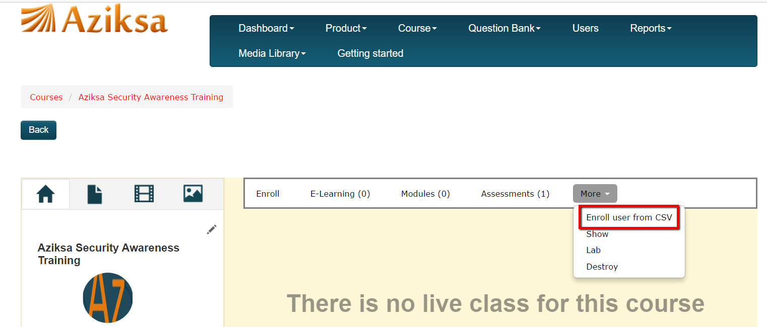

Browse the CSV file from your desktop. Click Submit

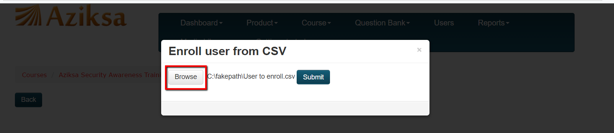

It will display a successful message. Click on Enroll button.

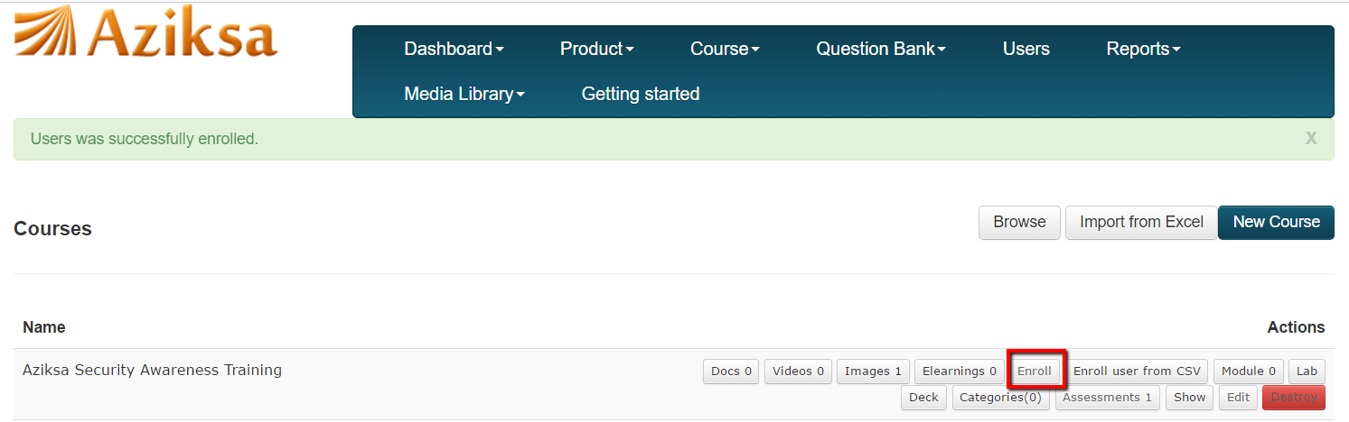

Next it will present you a list of unenrolled users (left column) and enrolled users (right column).
Click the checkbox next to unenrolled user and system will move the user to enrolled column. If a class has already started then it will ask you to change class dates, before you can enroll the users.

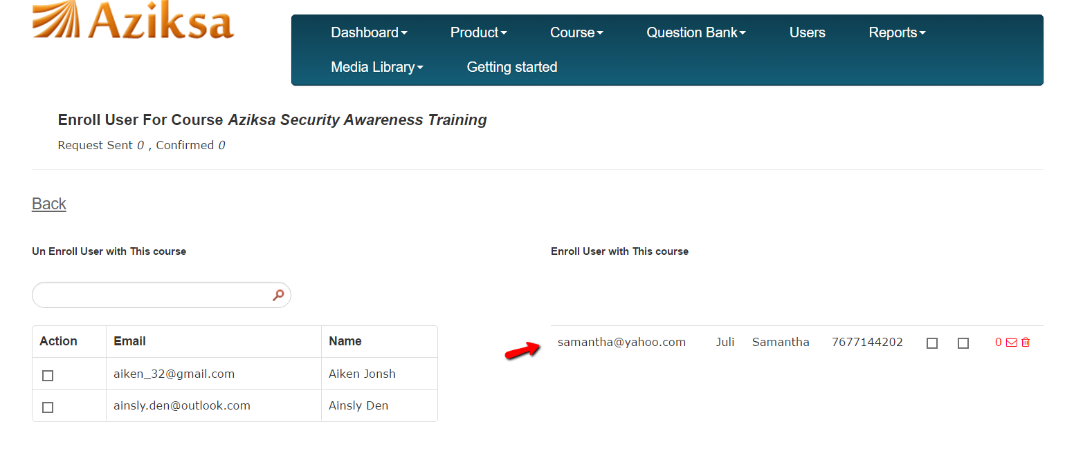

Click back button. It will take you course details page.

