Logout

Aziksa provides personalized dashboard for every role such as admin, end user and teacher.

For admin dashboard, click on dashboard menu and then sign out.

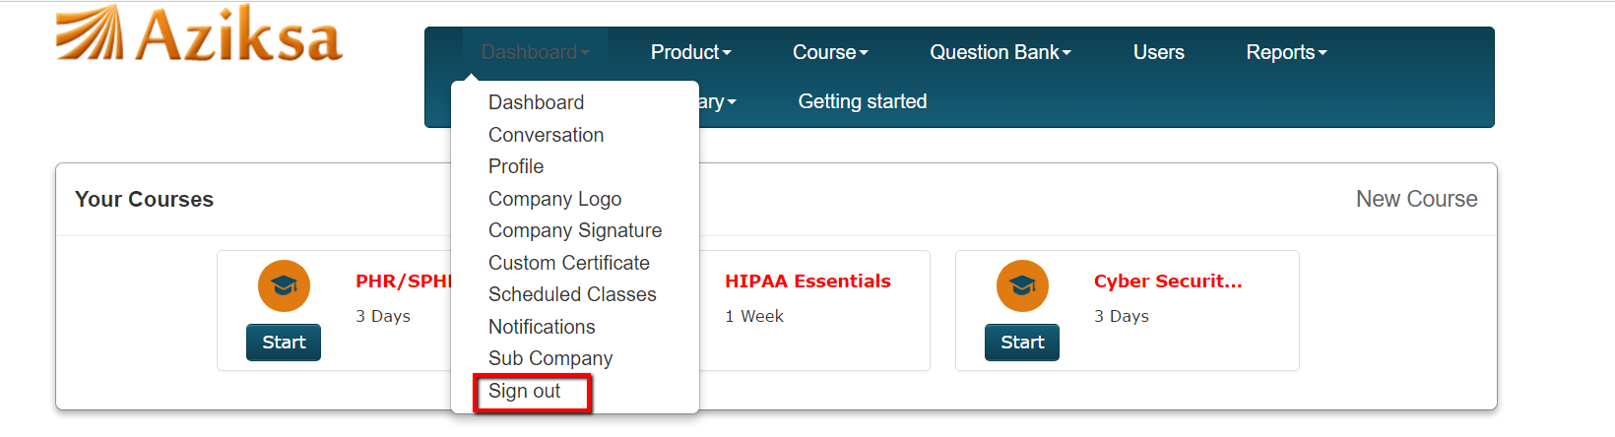

For end user dashboard, click on sign out button.

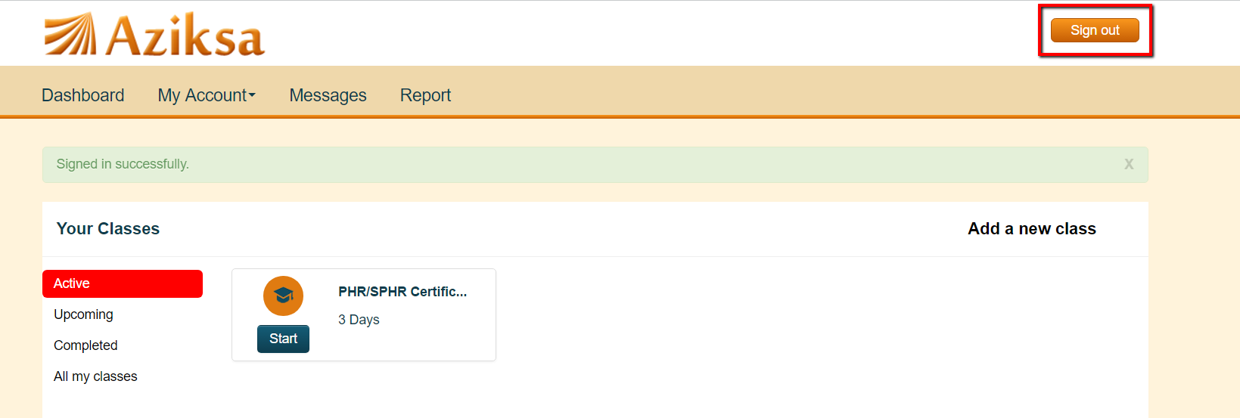

For Instructor dashboard, click on sign out button.

