Login
There are many ways to register at Aziksa website. You can do self-registration or your administrator can create one for you.

Once you have your user id and password, you can click on the login link and follow thru the prompts.

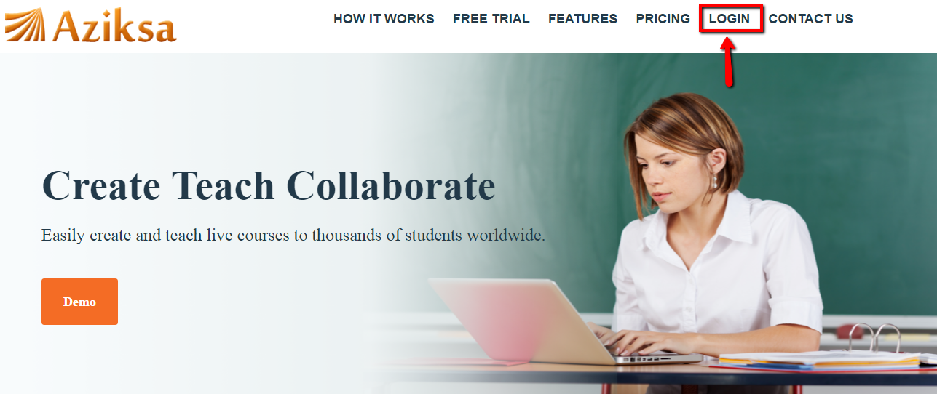

Enter your user id and password. Click Sign-In button.

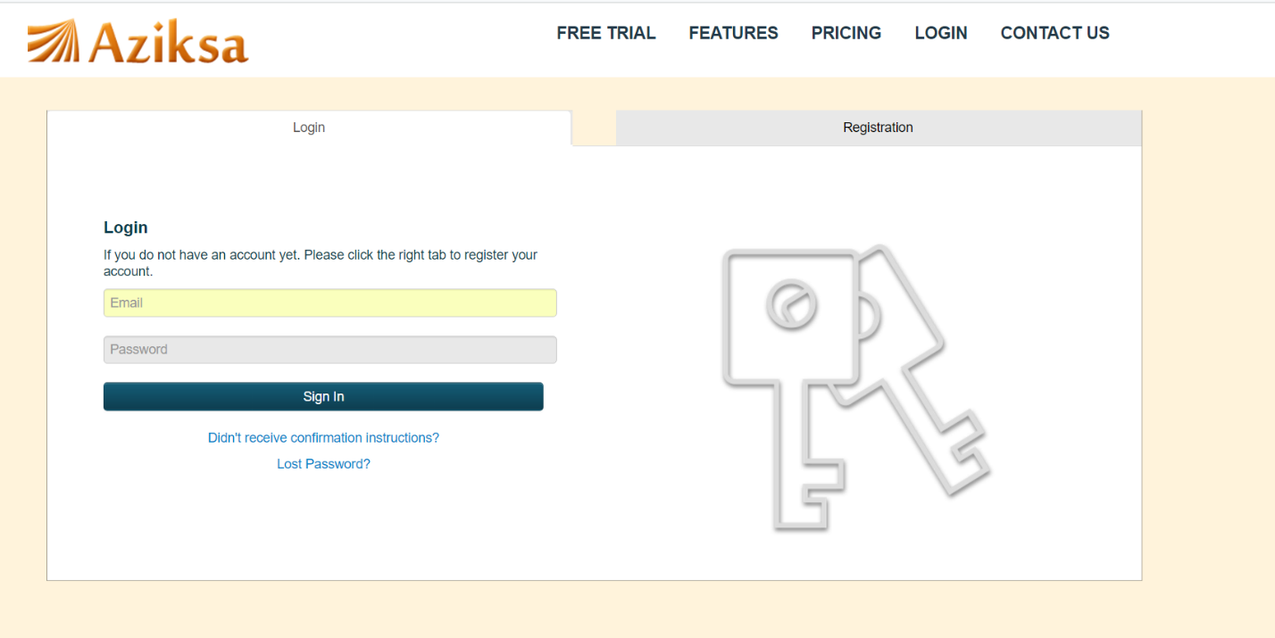

Now you will see your personalized dashboard. Aziksa provides personalized dashboard for every role such as admin, end user and teacher.

